Sunday, June 22nd, 2025
2nd Sunday after Pentecost
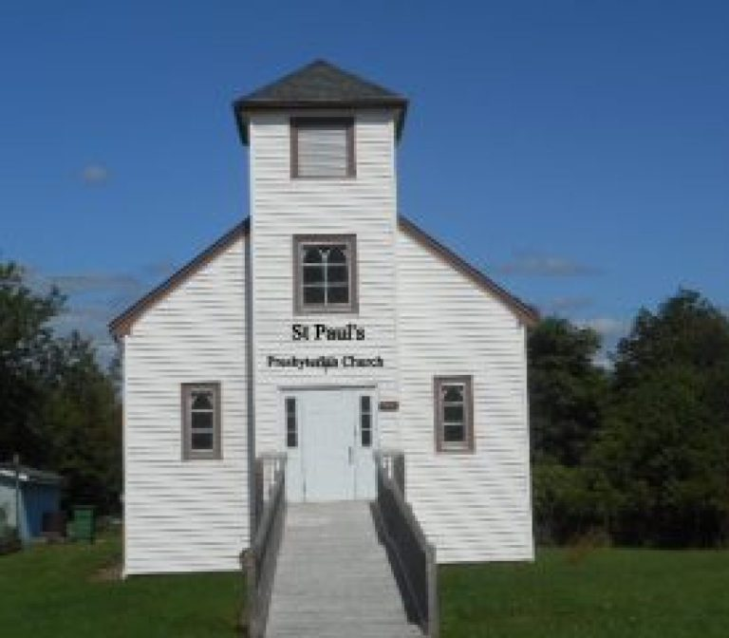

St. Paul’s Presbyterian Church
https://pccweb.ca/stpauls

Interim Moderator Rev. Robert Lyle 902-549-6411
Clerk of Session Jan Alchorn
Music Director Linda Giddens

ORDER OF WORSHIP
Call to Worship
We come to worship God,
For God is just and compassionate. God is love.
Where will we find God?
God is among the hungry and thirsty, in the face of a stranger, reaching out to us.
Let us seek God so that we can serve God.
Let us worship God and seek God’s healing, reconciling grace.
Hymn 18 As pants the hart
Prayers of Adoration and Confession (in unison)
Creator God, You have made a world of such amazing diversity – with unique living things we cannot number, in an interdependent pattern on which all life depends. We praise you for such wonder. We praise you for such wonder. In Jesus Christ, you show us how much you love your creation and how we can live by your love. By the power of your Spirit, give us new eyes to behold the wonders you have made and teach us how to share in the praise your creation offers you day by day.
Creator God, the diversity in your creation amazes us but we confess we prefer what seems familiar. We’d like everyone to speak our language. We wish others held our values and shared our customs. We don’t understand discrimination that hurts others. We don’t recognize how our own preferences affect other people and the earth itself in harmful ways. Forgive our familiar assumptions and open our minds and hearts to the stories of others and the cries of suffering throughout the earth. Amen.
Assurance of Pardon

WE HEAR GOD’S WORD
First Lesson I Kings 19:1-15a p. 255
Responsive Psalm 22:19-28
²¹ Rescue me from the mouth of the lions; save me from the horns of the wild oxen.
²² I will declare your name to my people; in the assembly I will praise you.
²³ You who fear the Lord, praise him! All you descendants of Jacob, honour him! Revere him, all you descendants of Israel!
²⁴ For he has not despised or scorned the suffering of the afflicted one; he has not hidden his face from him but has listened to his cry for help.
²⁵ From you comes the theme of my praise in the great assembly; before those who fear you, I will fulfill my vows.
²⁶ The poor will eat and be satisfied; those who seek the Lord will praise him — may your hearts live forever!
²⁷ All the ends of the earth will remember and turn to the Lord, and all the families of the nations will bow down before him,
²⁸ for dominion belongs to the Lord.
N.T. Epistle Galatians 3:23-29 p. 825
N.T. Gospel Luke 5:1-11 p. 728
Hymn 211 Speak Lord in the stillness
Sermon Finding God…
OUR RESPONSE TO THE WORD
Hymn 270 Lord God, the Holy Ghost
Offering and Offertory
Doxology (603)
Prayer of Dedication
Prayer of Thanksgiving & Intercession
The Apostles’ Creed (616)
WE GO OUT IN SERVICE
Hymn 291 Word of God, across the ages
Benediction and Choral Amen

MISSION MOMENT: Sunday, June 22
As the cost of living continues to rise across Saskatchewan, many individuals and families are finding it increasingly difficult to make ends meet. Saskatoon Native Circle Ministry (SNCM) recognizes that, in these challenging times, people need both physical and spiritual care. In addition to offering counselling and spiritual guidance, SNCM provides a safe space for those seeking comfort and direction. Through its drop-in centre, SNCM serves warm meals and offers a range of programs, including a mid-week worship service, an arts program, and both crisis and spiritual counselling. Rooted in First Nations traditions and gospel teachings, the ministry offers prayer, friendship, and hospitality to those in need. Over time, SNCM has flourished, not only in the number of people it serves but also in the depth of spiritual connections and the strength of the community bonds it fosters. SNCM receives support from Presbyterians Sharing.

This afternoon
Sam Graham will once again be with us for an afternoon of gospel music at 2pm. This is always a wonderful afternoon of music with Sam and friends. A friendship hour will be held after the service.

Summer Services

June 29 – Brad Little August 3 - Sára Katócz
July 5 – Bob Lyle August 10 – Maryann Skinner
July 12 – Bob Lyle August 17 – Brad Little
July 19 – Bob Lyle August 24 – Bob Lyle
July 26 – Brad Little August 31 – Maryann Skinner

