St. Paul’s Presbyterian Church
Sunday, March 1st, 2026
9:30 am

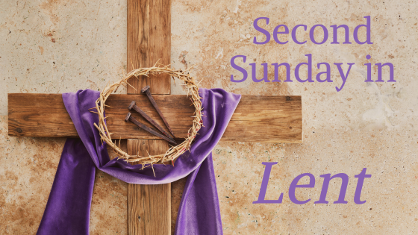

https://pccweb.ca/stpauls

Interim Moderator Rev. Robert Lyle 902-549-6411
Clerk of Session Jan Alchorn
Music Director Linda Giddens

ORDER OF WORSHIP
Call to Worship
Into life’s challenges and questions comes the Mystery of God,
and God’s truth opens our eyes.
Into our routines and rituals walks the presence of Christ,
and God’s love brings healing and hope.
Into our traditions and conclusions blows the wind of the Spirit,
and God’s people are born from above.
We gather in Jesus’ name to encounter God’s grace and glory.
Let us worship God with open hearts and minds.
Hymn 54 Unto the hills, around do I lift up
Prayers of Adoration and Confession (in unison)
God of majesty and mercy, Christ, both Lord and Servant, Spirit of new life, your mystery embraces the vast reaches of the universe and yet you are present with us in the course of our daily lives. Even the tiniest spark of your wisdom illuminates the greatest complexities. With the smallest gesture of your love, you renew our hope. Deepen our sense of your holy presence this day. Assure us that your love will never let us go. We offer our praise and our prayers this day to you, Holy God, Holy One and Holy Three, with humble hearts and faith that seeks understanding.
God of mystery and mercy, we confess that we prefer simple certainty to seeking deeper understanding. We settle for what we know, ignoring our doubts and questions. Forgive us when our faith falters because what we think no longer satisfies. Open our eyes to the truth you hold out to us in Christ and give us courage to rethink what we have assumed about you and your love for the world. Faithful God, you sent Jesus Christ to seek and save the lost yet it’s hard to recognize we have lost our way. We seek the next new thing instead of your gift of new life. We follow the trends of our culture rather than Jesus’ example. Wash over us with your cleansing Spirit and renew our commitment to follow your purposes revealed in Christ Jesus. Amen.
Assurance of Pardon
The Apostle Paul declared that from now on, we regard no one from a human point of view. If anyone is in Christ, there is a new creation. Everything old has passed away; see, everything has become new! Thanks be to God for love that gives us all a new start this very day!
WE HEAR GOD’S WORD
O. T. Lesson Genesis 12:1-4a p. 8
Second Sunday in Lent Liturgy (on insert)
Responsive Psalm 121
I look up to the mountains; does my strength come from mountains?
No, my strength comes from God, who made heaven, and earth, and mountains.
He won’t let you stumble; your Guardian God won’t fall asleep.
Not on your life! Israel’s Guardian will never doze or sleep.
God’s your Guardian, right at your side to protect you — Shielding you from sunstroke, sheltering you from moonstroke.
God guards you from every evil, he guards your very life.
He guards you when you leave and when you return, he guards you now, he guards you always.
N.T. Epistle Lesson Romans 4:1-5, 13-17 p. 497
N.T, Gospel Lesson John 3:1-17 p. 751
Hymn 233 Love divine, all loves excelling
Sermon God so loved the world
OUR RESPONSE TO THE WORD
Hymn 230 When morning gilds the skies
Offering and Offertory
Doxology (603)
Prayer of Dedication
Prayer of Thanksgiving & Intercession
The Apostles’ Creed (616)
WE GO OUT IN SERVICE
Hymn 454 Take up thy cross
Benediction and Choral Amen

MISSION MOMENT Sunday, March 1, 2026
After Susheela Devi’s husband died from a chronic illness, she struggled to support her four daughters while running a small cosmetic shop. To ease her financial burdens, two of her daughters were forced into early marriage, and one tragically died during childbirth, leaving Susheela to care for the newborn. With insufficient government aid, her remaining daughters dropped out of school. Through the Karuna Project in India, PWS&D provided resources to help Susheela revive her cosmetic business, enabling her to support her family. The project also educated her on the dangers of child marriage, prompting her to re-enroll her daughters in school and invest in their futures. Determined, she says, “I will make them study well so they are capable of taking care of themselves.”

Upcoming Services
March 8 Brad Little March 15 Maryann Skinner
March 22 Bob Lyle March 29 Brad Little

Annual Meeting
Monday, March 16 We will meet for lunch at noon, and meeting will follow immediately afterwards. Please get reports to Jan asap.

