St. Paul’s Presbyterian Church
Sunday, March 22nd, 2026
9:30 am

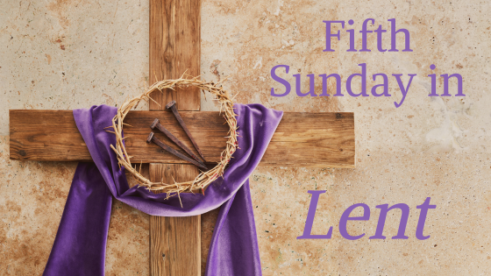

https://pccweb.ca/stpauls

Interim Moderator Rev. Robert Lyle 902-549-6411
Clerk of Session Jan Alchorn
Music Director Linda Giddens

ORDER OF WORSHIP
Call to Worship
More than those who watch for the morning,
we wait faithfully for God.
With our questions and our cries, in our hopes and expectations,
we wait faithfully for God.
Come, let us worship the Lord our God together,
and offer our prayers and praise in faithfulness.
Hymn 237 All hail the power of Jesus name
Prayers of Adoration and Confession (in unison)
God in whom we live and move and have our being, we praise you. In the face of all that wearies us and worries us, your Word echoes across the centuries with hope. As we follow the footsteps of Jesus in this Lenten season, his Cross standing before us, we trust you are never far from our sorrows, walking with us; sharing our tears. You stand beside us when we don’t know which way to turn. In this time of worship, renew our trust in your resurrection promises. Draw near to us when we need you the most with love that will never let us go. We offer you our wonder and our praise as the creating God, leading Christ, and inspiring Spirit.
Merciful God, we confess that we have sinned against you in thought, word, and deed, by what we have done, and by what we have left undone. We have not loved you with our whole heart; we have not loved our neighbors as ourselves. Have mercy on us and forgive us; so that we may delight in your will, and walk in your ways, to the glory of your Name. Amen.
Assurance of Pardon
Jesus said, “Come to me all you who labour and are heavy laden and I will give you rest.” Trust that peace and forgiveness are God’s gift to you this day, whatever burden you carry. Be renewed by the breath of the Holy Spirit that will bring you into each new day.
WE HEAR GOD’S WORD
O. T. Lesson Ezekiel 37:1-14 p. 614
Fifth Sunday in Lent Liturgy (on insert)
Responsive Psalm 130 BOP 633
N.T. Epistle Lesson Romans 8:6-11 p. 800
N.T, Gospel Lesson John 11:1-45 p. 760
Hymn 123 (SoG) Jesus is all the world to me
Sermon Dead? No alive in me
OUR RESPONSE TO THE WORD
Hymn 259 Breathe on me, breath of God
Offering and Offertory
Doxology (603)
Prayer of Dedication
Prayer of Thanksgiving & Intercession
The Apostles’ Creed (616)
WE GO OUT IN SERVICE
Hymn 536 Blest be the everlasting God
Benediction and Choral Amen

MISSION MOMENT Sunday, March 1, 2026
The PCC is dedicated to embracing the commitments made in the 2024 Apology, acknowledging the church’s past role in colonization and residential schools. We are committed to listening to and sharing the truth about those histories and actively supporting Indigenous-led healing and wellness efforts. Many of these efforts are carried out through the eight ministries of the National Indigenous Ministries Council, with support from Presbyterians Sharing. These ministries serve Indigenous communities across Canada by creating welcoming and safe spaces that offer crisis counselling, meals, children’s programs, worship Circles, and more. Additionally, the church is working on healing projects supported by the Honouring the Children fund, which funds initiatives identified by Indigenous nations and communities impacted by PCC-run schools. These projects include memorials, healing gardens, searches of former school sites, community events like feasts and gatherings, and other meaningful efforts to heal the wounds of the past.

Upcoming Services
March 29 Brad Little Palm Sunday & Communion Service
April 5 Maryann Skinner Easter
April 12 Bob Lyle

