St. Paul’s Presbyterian Church
Sunday, April 12th, 2026
2nd Sunday of Easter
9:30 am
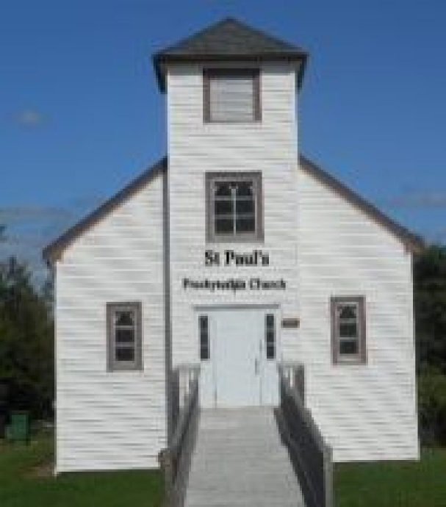

https://pccweb.ca/stpauls

Interim Moderator Rev. Robert Lyle 902-549-6411
Clerk of Session Jan Alchorn
Music Director Linda Giddens

ORDER OF WORSHIP

Call to Worship
All things of God, all the heavens,
Worship and praise your Maker.
Sun, moon and stars; wind, rain and thunder,
Worship and praise your Maker.
Mountains and forests, streams and waterfalls,
Worship and praise your Maker.
Creatures beneath the seas, birds throughout the skies,
all that leaps or crawls, all who walk or worry or wonder,
Let us worship and praise our Maker together.
Hymn 193 The day of resurrection
Prayers of Adoration and Confession (in unison)
Glory to you, O God our Maker, we come giving thanks for the wonder in your creation, the great theatre of your glory. Glory to you, O Christ we come praising you, for you overcame death and opened the gate of everlasting life to us. Glory to you, O Holy Spirit, we come praising you for your guidance, wisdom and inspiration. Glory to you, Holy Trinity, source of all truth, love, hope and joy, now and always. To begin again with you and one another, we confess to you our sins:
God our Redeemer, in raising Christ from the dead, you showed us your power to defeat all that brings fear and sorrow to our lives. Yet when things go wrong, we confess we are sometimes uncertain how to find him. Like Thomas, we are unsure if we can trust the promise of resurrection. Forgive us when we struggle with doubt about your presence with us.
Breathe your Spirit upon us and bring us the peace Christ promised. Amen.
Assurance of Pardon
Friends, the risen Christ is in our midst, speaking words of peace and forgiveness to us this day. Do not doubt these gifts are for you. Be at peace with yourself and with one another. Amen.
WE HEAR GOD’S WORD
O. T. Lesson Exodus 15:1–11 p. 50
Responsive Psalm 111 BOP 655
N.T. Epistle Lesson 1 Peter 1:3-9 p. 857
N.T, Gospel Lesson John 20:19-31 p. 769
Hymn Tis so sweet to trust in Jeus
’Tis so sweet to trust in Jesus, and to take Him at His word;
Just to rest upon His promise, and to know, thus says the Lord!

Refrain
Jesus, Jesus, how I trust Him! How I’ve proved Him o’er and o’er
Jesus, Jesus, precious Jesus! O for grace to trust Him more!

O how sweet to trust in Jesus, just to trust His cleansing blood;
And in simple faith to plunge me ’Neath the healing, cleansing flood!

Yes, ’tis sweet to trust in Jesus, just from sin and self to cease;
Just from Jesus simply taking Life and rest, and joy and peace.

I’m so glad I learned to trust Thee, precious Jesus, Saviour, friend;
And I know that Thou art with me, wilt be with me to the end.
(Public Domain)

Sermon Believing the unbelievable
OUR RESPONSE TO THE WORD
Hymn 484 I’m not ashamed to own my Lord
Offering and Offertory
Doxology (603)
Prayer of Dedication
Prayer of Thanksgiving & Intercession
The Apostles’ Creed (616)
WE GO OUT IN SERVICE
Hymn 454 Take up Thy cross
Benediction and Choral Amen

MISSION MOMENT Sunday, April 12th, 2026
World Health Day aims to raise awareness about global health issues and promote actions to improve health and well-being worldwide. However, due to substantial cuts to global health funding in 2025, many communities and individuals have lost access to essential health programs. PWS&D collaborates with partners to support health initiatives in difficult environments. In Haiti, for example, PWS&D, in partnership with the Center for Nutrition and Education for Women & Children, is supporting maternal and infant malnutrition treatment and women’s mental health. For Choute Philomène, 34, the program is a welcome initiative. She was glad to receive maternal health support at her home, as she had planned to skip prenatal follow-up during her pregnancy.
Upcoming Services
April 19 Brad Little Fellowship Sunday
April 26 Maryann Skinner
May 5 Bob Lyle

