St. Paul’s Presbyterian Church
Sunday, May 3rd, 2026
5th Sunday of Easter
9:30 am
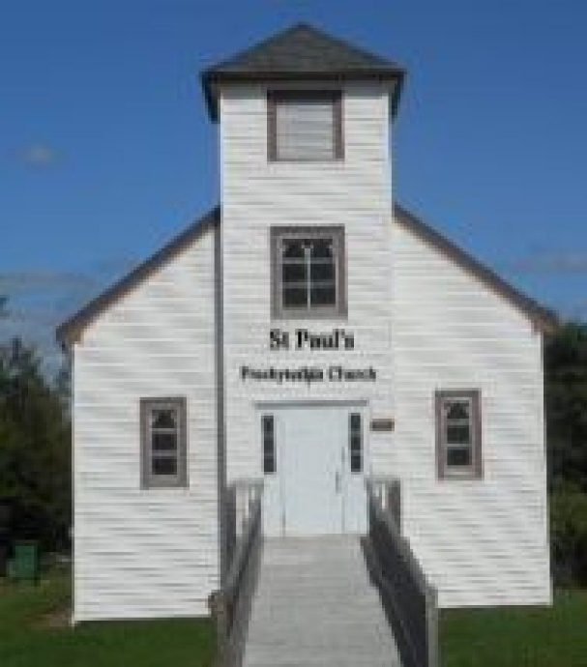

https://pccweb.ca/stpauls

Interim Moderator Rev. Robert Lyle 902-549-6411
Clerk of Session Jan Alchorn
Music Director Linda Giddens

ORDER OF WORSHIP

Call to Worship
God is our Rock and our Fortress.
In God, we find refuge and strength.
God’s house has many dwelling places.
We will dwell in the house of the Lord forever.
Christ himself has gone to prepare a place for us.
For us, Jesus is the way, the truth and the life.
So let us worship God in Spirit and in Truth.
Hymn 357 How sweet the name of Jesus sounds
Prayers of Adoration and Confession (in unison)
Steadfast God, you are our refuge in times of trouble, our shelter when we are afraid, and our dwelling place forever. In you alone we place our trust for you set the way before in Christ Jesus and your Spirit gives us courage to follow him. And so, we offer you our worship and love as the Source of life for the world, as the Son who preached the truth of grace and mercy, and the Spirit who guides us this day and always.
Trusting in who you are, knowing who we are and what we have done, we confess to you our sins:
Steadfast God, we confess Jesus as the way, the truth and the life for us, yet we often fail to follow him, too often gone our own way, distorted the truth and led hollow lives. Forgive us for falling short of your purpose for our lives. Give us courage to follow Jesus, who continues to show us the way. Amen.
Assurance of Pardon
Do not let your hearts be troubled. Know that, in Christ, you are forgiven. Accept God’s grace and forgiveness this day and extend it to others for Jesus’ sake. Amen.
WE HEAR GOD’S WORD
First Lesson Acts 7:55-60 p. 776
Responsive Psalm 31:1-5, 15-16
¹ In you, Lord, I have taken refuge; let me never be put to shame; deliver me in your righteousness.
² Turn your ear to me, come quickly to my rescue; be my rock of refuge, a strong fortress to save me.
³ Since you are my rock and my fortress, for the sake of your name lead and guide me.
⁴ Keep me free from the trap that is set for me, for you are my refuge.
⁵ Into your hands I commit my spirit; deliver me, Lord, my faithful God.
¹⁵ My times are in your hands; deliver me from the hands of my enemies, from those who pursue me.
¹⁶ Let your face shine on your servant; save me in your unfailing love.
N.T. Epistle Lesson 1 Peter 2:2-10 p. 857
N.T, Gospel Lesson John 14:1-14 p. 763
Hymn 479 The church’s one foundation
Sermon The Way, the Truth and the Life
OUR RESPONSE TO THE WORD
Hymn 569 O Jesus, I have promised
Offering and Offertory
Doxology (603)
Prayer of Dedication
Prayer of Thanksgiving & Intercession
The Apostles’ Creed (616)
WE GO OUT IN SERVICE
Hymn 332 How great Thou art
Benediction & Choral Amen

MISSION MOMENT
Sunday, May 3rd, 2026
With support from Presbyterians Sharing, the Presbytery of Assiniboia’s Messy Church meets eight times a year across three congregations: First (Regina), Trinity (Grenfell), and Knox (Weyburn). Coordinated by the synod’s Youth Coordinator, the Rev. Devon Pattemore, each session features crafts, a themed story, worship, and a shared meal. Designed to engage families unable to attend Sunday worship, it has revitalized struggling congregations, built confidence, and drawn both church members and local families. In some locations, attendance now surpasses traditional services. Messy Church offers flexible, informal faith formation, strengthens community connections, and provides a creative, welcoming space for intergenerational ministry.

Upcoming Services
May 10 Brad Little Christian Family/Mother’s Day
May 17 Maryann Skinner Fellowship Sunday
May 24 Bob Lyle Pentecost
May 31 Brad Little

