St. Paul’s Presbyterian Church
Sunday July 5, 2026
6th Sunday after Pentecost
9:30 am
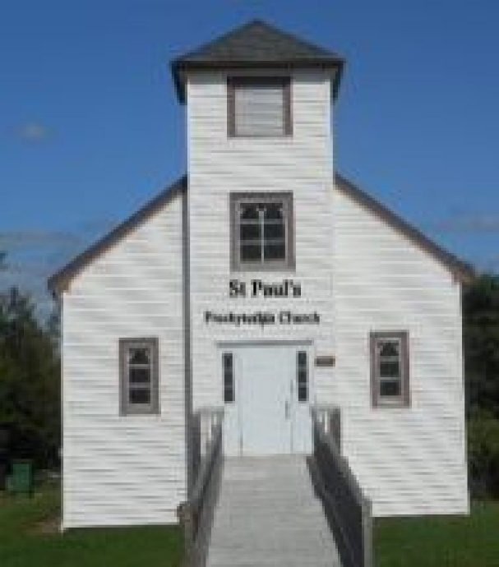

https://pccweb.ca/stpauls

Interim Moderator Rev. Robert Lyle 902-549-6411
Clerk of Session Jan Alchorn
Music Director Linda Giddens

ORDER OF WORSHIP
Call to Worship
God is gracious and merciful, abounding in steadfast love.
God offers compassion to all creation.
With all God’s creation, give thanks to the Lord.
With all God’s creatures, great and small, we will bless the Lord.
In worship let us speak of God’s glory and tell of God’s wonder.
We come to praise God and seek God’s peace in Jesus’ name.
Hymn 64 O Lord, Thou art, my God and King
Prayers of Adoration and Confession (in unison)
Holy, gracious and merciful God, you are overflowing with love, infinite in kindness, and incomparable in glory. There is no other like you in all our imagining. Your presence breaks into our lives, reflected in the beauty of creation, and refreshes and inspires us. You renew us to imagine new things; you strengthen us to meet life’s changes and challenges. In response to your goodness and glory, we offer you our thanks in the words of our prayers, and the praise from our hearts. We honour you with our lives, worshipping you as Creator, Redeemer and Sustainer, this day and every day, now and always. In confidence of your grace and loving kindness we confess to you our sins: Wise and patient God, you offer us peace, yet we confess life often feels frustrating and unsettled. You offer us courage, yet we are timid and resentful when life is challenging. You offer us a mission with meaning and purpose, yet we are preoccupied with our own plans and desires. Forgive us, O God, and draw our attention back to you. Amen.
ASSURANCE OF PARDON
Jesus said, “Come to me all you who labour and are heavy laden and I will give you rest”. Trust that peace and forgiveness are God’s gifts to you this day. Be renewed by the power of the Spirit that moves with you into each new day.
WE HEAR GOD’S WORD
First Lesson Genesis 24:34-38, 42-49, 58-67 p. 16
Responsive Psalm 45:10-17
¹⁰ Listen, daughter, and pay careful attention: Forget your people and your father’s house.
¹¹ Let the king be enthralled by your beauty; honour him, for he is your lord.
¹² The city of Tyre will come with a gift, people of wealth will seek your favour.
¹³ All glorious is the princess within her chamber; her gown is interwoven with gold.
¹⁴ In embroidered garments she is led to the king; her virgin companions follow her — those brought to be with her.
¹⁵ Led in with joy and gladness, they enter the palace of the king.
¹⁶ Your sons will take the place of your fathers; you will make them princes throughout the land.
¹⁷ I will perpetuate your memory through all generations; therefore the nations will praise you for ever and ever.
N.T. Epistle Lesson Romans 7:15-25 p. 800
N.T. Gospel Lesson Matthew 11:16-19, 25-30 p. 689
Hymn 369 I heard the voice of Jesus say
Sermon Doing what we’re supposed to do
OUR RESPONSE TO THE WORD
Hymn 474 Take my life and let it be
Offering and Offertory
Doxology (603)
Prayer of Dedication
Prayer of Thanksgiving & Intercession
The Apostles’ Creed (616)
WE GO OUT IN SERVICE
Hymn 477 Lord, speak to me
Benediction & Choral Amen

MISSION MOMENT: Sunday, July 5th
At 16, Ahmad Reza carries heavy responsibilities. Living in Bamyan, Afghanistan, he was orphaned by the loss of both parents, becoming the main support for his family. He cares for his two younger brothers and lives with his sister’s family, who also face extreme poverty. The winter months are particularly difficult as food becomes scarce. Overwhelmed by grief and financial pressure, Reza was forced to leave school. He now works as an apprentice at a garage to gain skills for his family’s future. Relief came when Reza’s family received three months of cash assistance through a winter cash-for-food program supported by PWS&D. “For the first time in months, the constant worry about our next meal has eased,” he said. Reza hopes his training will soon allow him to support his family fully.
Upcoming Services
July 12th Brad Little
June 19th Mary Ann Skinner
June 26th Brad Little

