St. Paul’s Presbyterian Church
Sunday August 9th, 2026
12th Sunday after Pentecost
9:30 am

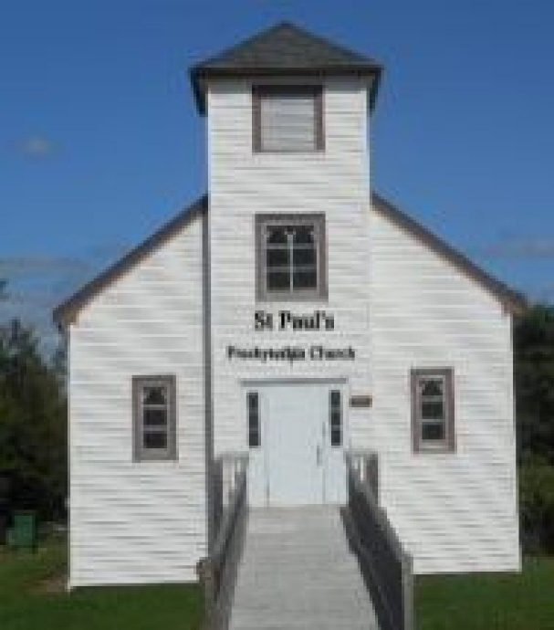

https://pccweb.ca/stpauls

Interim Moderator Rev. Robert Lyle 902-549-6411
Clerk of Session Jan Alchorn
Music Director Linda Giddens

ORDER OF WORSHIP
Call to Worship
Give thanks to God!
We will tell the world what God has done.
Let us bring praise to the name of our Creator.
We will honour God’s name with shouts of joy!
Recall all that God provides.
Let us give thanks for all the wonders God has made!
Hymn 42 All people that on earth do dwell
Prayers of Adoration and Confession (in unison)
Surprising and mysterious God, you come to us when we least expect it, calling us out of our routines and plans, inviting us to follow Christ into new opportunities. We praise you for the many ways your Spirit guides and comforts us. In moments of fear, you speak with words of reassurance. In moments of doubt, you reach out your hand to hold. In moments of turmoil, you bring calm to the storm; and so, we place our trust in you this day and every day, and honour you as our Creator, Redeemer and Guide, in the name of Christ, our Lord and friend we pray.
Recalling your grace and kindness, and out of a desire to begin again with you and each other, we confess to you our sins:
Merciful and patient God, we confess our fear, doubt and anger and all the ways we are less than you call us to be. You call us to live with courage and perseverance, yet we give up too easily and opt for the safer route. You encourage us to be bold in our struggles for justice, yet we remain silent in the face of unfairness. You command us to love, yet we are too often thoughtless and cruel. Forgive us our sins and. renew our lives through your mercy and grace. Amen.

ASSURANCE OF PARDON
God offers forgiveness and saving grace to everyone. Accept these gifts for yourselves and offer forgiveness to others in the name of Christ our Lord.
WE HEAR GOD’S WORD
First Lesson Genesis 37:1–4, 12–28 p. 28
Responsive Psalm Psalm 105:1–6, 16–22
¹ Give praise to the Lord, proclaim his name; make known among the nations what he has done.
² Sing to him, sing praise to him; tell of all his wonderful acts.
³ Glory in his holy name; let the hearts of those who seek the Lord rejoice.
⁴ Look to the Lord and his strength; seek his face always.
⁵ Remember the wonders he has done, his miracles, and the judgments he pronounced,
⁶ you his servants, the descendants of Abraham, his chosen ones, the children of Jacob.
¹⁶ He called down famine on the land and destroyed all their supplies of food;
¹⁷ and he sent a man before them — Joseph, sold as a slave.
¹⁸ They bruised his feet with shackles, his neck was put in irons,
¹⁹ till what he foretold came to pass, till the word of the Lord proved him true.
²⁰ The king sent and released him, the ruler of peoples set him free.
²¹ He made him master of his household, ruler over all he possessed,
²² to instruct his princes as he pleased and teach his elders wisdom.
N.T. Epistle Lesson Romans 10:5–15 p. 802
N.T. Gospel Lesson Matthew 14:22–33 p. 692
Hymn 101 God moves in a mysterious way
Sermon A story of brothers
OUR RESPONSE TO THE WORD
Hymn 513 Lead us, heavenly Father, lead us
Offering and Offertory
Doxology (603)
Prayer of Dedication
Prayer of Thanksgiving & Intercession
The Apostles’ Creed (616)
WE GO OUT IN SERVICE
Hymn 469 O Master, let me walk with Thee
Benediction & Choral Amen

MISSION MOMENT: Sunday, August 9th
Abena Asabiliga, a 46-year-old woman from Sumaduri in the Garu District of Northern Ghana, became physically impaired in infancy due to polio. Because of stigma, discrimination and her family’s poverty, she lived an isolated and difficult life. After being identified in a community survey by community-based rehabilitation staff working for the Presbyterian Church of Ghana, her family and community received sensitization on disability rights, which helped reduce negative attitudes. With support from PWS&D, Abena received a tricycle for mobility, business skills training and start-up capital. She now sells snacks near a school and earns a living. She said, “My life has changed, and I can now move independently with the use of the tricycle that was provided to me. I am so grateful.”

Upcoming Services
Aug 16 – Maryann Skinner Aug 23 – Bob Lyle Aug 30 – Brad Little

