St. Paul’s Presbyterian Church
Sunday August 23rd, 2026
15th Sunday after Pentecost
9:30 am

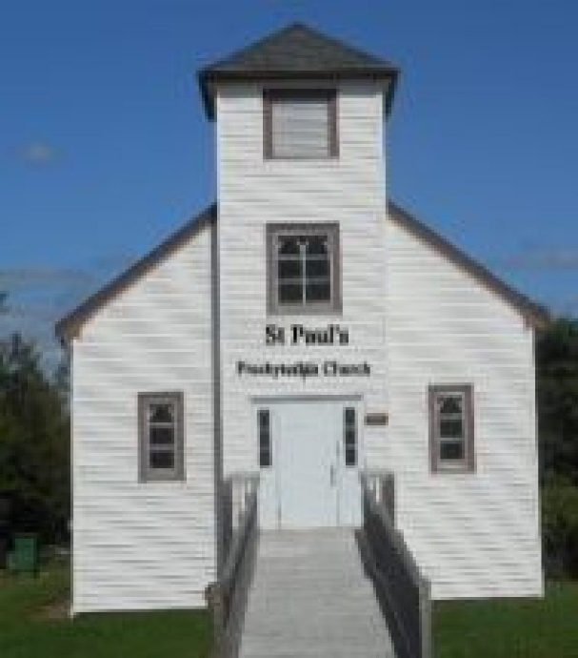

https://pccweb.ca/stpauls

Interim Moderator Rev. Robert Lyle 902-549-6411
Clerk of Session Jan Alchorn
Pianist Cathy Weldin

ORDER OF WORSHIP

Call to Worship
We give thanks to God with all our hearts,
for God’s faithful love endures forever.
We sing praises to the Lord, with all our strength,
for God’s promises declare God’s goodness to all the earth.
We place our trust in in God with full confidence,
and we come to worship with hearts full of praise.
Hymn 72 All creatures of our God and King
Prayers of Adoration and Confession (in unison)
Eternal God, you are the same yesterday, today and tomorrow, and yet you come to us afresh each new day. You breathe new life into what has grown tired and discouraged. You offer healing for what is worn or broken. You restore hope when things seem impossible. You are the source of life and love for all your creatures, and you renew us to put our love for you into action for the wellbeing of your creation. And so, we worship you, Creator, Christ and Holy Spirit, and offer our prayers and praise to you, eternal and ever-present God, now and always.
Confident of your grace and loving kindness, we confess to you, our sins.
Merciful God, we confess that we have strayed from your purposes. You set a path for us to follow, but we conform to the ways of this world. You give each of us gifts to use for the work of your kingdom, but we wait for others to do what needs doing. Forgive us for taking the easy way out and renew in us the eagerness and energy to serve.
ASSURANCE OF PARDON
Hear the good news! Who is in a position to condemn us? Only Christ – and Christ died for us, Christ rose for us, Christ reigns in power for us, Christ prays for us. In Jesus Christ, we are forgiven and set free by God’s generous grace. So let us make a fresh start today!
WE HEAR GOD’S WORD
First Lesson Exodus 1:8–2:10 p. 40
Responsive Psalm Psalm 124
1 If the Lord had not been on our side — let Israel say —
2 if the Lord had not been on our side when people attacked us,
3 they would have swallowed us alive when their anger flared against us,
4 the flood would have engulfed us, the torrent would have swept over us,
5 the raging waters would have swept us away.
6 Praise be to the Lord, who has not let us be torn by their teeth.
7 We have escaped like a bird from the fowler’s snare; the snare has been broken, and we have escaped.
8 Our help is in the name of the Lord, the Maker of heaven and earth.
N.T. Epistle Lesson Romans 12:1–8 p. 803
N.T. Gospel Lesson Matthew 16:13–20 p. 694
Hymn 387 O Spirit of the living God
Sermon Baby Moses
OUR RESPONSE TO THE WORD
Hymn 375 Sing them over again to me
Offering and Offertory
Doxology (603)
Prayer of Dedication
Prayer of Thanksgiving & Intercession
The Apostles’ Creed (616)

WE GO OUT IN SERVICE
Hymn 401 Tell me the old, old story
Benediction & Choral Amen

We welcome Cathy Weldin as our pianist this morning.

MISSION MOMENT: Sunday, August 23

On World Humanitarian Day, we recognize and celebrate the efforts of humanitarian workers who provide life-saving assistance to millions of people affected by conflicts, natural disasters and other emergencies. Whatever their faith, they are the living examples of what Jesus asked us to do. We give thanks for PWS&D’s partners, who work tirelessly to ensure that essential food aid gets delivered, devastated communities are rebuilt and access to life-saving resources is within reach. Humanitarian workers play a crucial role in ensuring the welfare of vulnerable and marginalized people. Through collaborative efforts, we work together to build a sustainable, compassionate and just world. With daily reports of so many struggling around the world, let us take a moment today to honour these selfless advocates and offer unwavering support for their vital efforts.

Upcoming Services
Aug 30 – Brad Little
Sept 6 – Maryann Skinner
Sept 13 – Bob Lyle
Sept 20 – Brad Little (Fellowship Sunday)
Sept 27 – Maryann Skinner
Oct 4 – Bob Lyle (Fall Communion)

