St. Paul’s Presbyterian Church
Sunday September 13th, 2026
18th Sunday after Pentecost
9:30 am

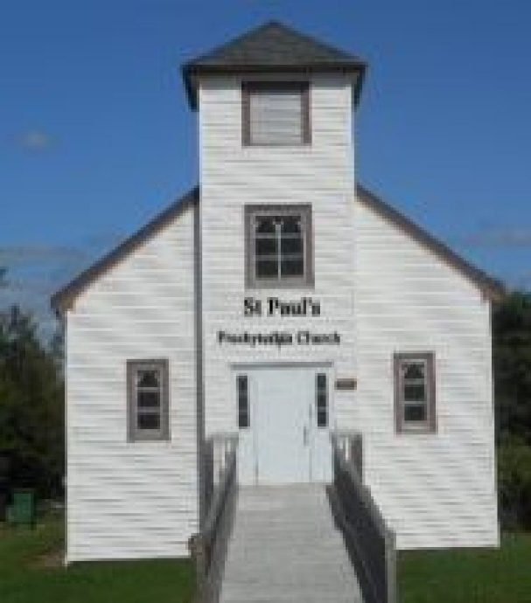

https://pccweb.ca/stpauls

Interim Moderator Rev. Robert Lyle 902-549-6411
Clerk of Session Jan Alchorn
Pianist Linda Giddens

ORDER OF WORSHIP
Call to Worship
Praise the God of life.
Let us praise God together.
For as the heavens are high above the earth, so great is God’s steadfast love; as far as the east is from the west, so far God removes our sins.
So let us rejoice in God’s gracious presence.
Let us praise the God of mercy together.
Hymn 322 God reveals His presence
Prayers of Adoration and Confession (in unison)
God of might and mercy, the heavens and the earth are full of your glory. Your love transforms our lives. You enter our confusion and give insight. You bear our grief and bring healing. You see our fatigue and renew strength. You sense our fear and spark courage. You know death and raise up new life. So, we come before you in worship, handing over to you all that weighs us down. Renew us in this time of worship, we pray, so that we may serve you with joy in Jesus’ name. Out of a desire to begin again with you and one another, we confess to you our sins:
Merciful God, our lives do not always reflect your transforming power. You are gracious, but we cling to judgment. You are kind, but we can be cruel. You are forgiving, but we nurse grudges and old wounds. Forgive us, O God. Fill us with your Holy Spirit, and make us new through Christ, your Son and our Saviour. Amen.
ASSURANCE OF PARDON
The proof of God's amazing love is this: that while we were sinners, Christ died for us. Know that you are forgiven by his grace and be at peace with God, with yourselves and with
each other. Amen.
WE HEAR GOD’S WORD
First Lesson Exodus 14:19-31 p. 50
Responsive Psalm Psalm 114
¹ When Israel came out of Egypt, Jacob from a people of foreign tongue,
² Judah became God’s sanctuary, Israel his dominion.
³ The sea looked and fled, the Jordan turned back;
⁴ the mountains leaped like rams, the hills like lambs.
⁵ Why was it, sea, that you fled? Why, Jordan, did you turn back?
⁶ Why, mountains, did you leap like rams, you hills, like lambs?
⁷ Tremble, earth, at the presence of the Lord, at the presence of the God of Jacob,
⁸ who turned the rock into a pool, the hard rock into springs of water.
N.T. Gospel Lesson Matthew 18:21-35 p. 695
Hymn 23 SoG In the garden
Sermon Encountering God
OUR RESPONSE TO THE WORD
Hymn 508 All the way my Savour leads me
Offering and Offertory
Doxology (603)
Prayer of Dedication
Prayer of Thanksgiving & Intercession
The Apostles’ Creed (616)

WE GO OUT IN SERVICE
Hymn 503 Guide me, O Thou great Jehovah
Benediction & Choral Amen

MISSION MOMENT: Sunday, September 13
Although today’s global food production is sufficient to feed everyone on the planet, hunger continues to rise in too many parts of the world. If current trends continue, around 512 million people may still be chronically undernourished in 2030. This September, join PWS&D’s annual Journey for Hope—a fundraiser where PWS&D’s supporters gear up and walk, run, ride or do another activity they love to raise money for vital food security work around the world. Your participation in and support for Journey for Hope enables PWS&D to actively respond to hunger through food security projects in places like Haiti, Guatemala and Malawi. Funds also help provide emergency food assistance in extremely vulnerable countries, including Afghanistan, Yemen, Syria, Somalia, South Sudan and Ethiopia. Thank you for participating and making a difference!

Upcoming Services
Sept 20 – Brad Little
Sept 27 – Maryann Skinner
1-3pm There will be an Open House to celebrate Leota’s 90th birthday at 337 Brookside Branch Road across from Blenkhorns Auto Salvage.
2 pm Sam Graham and friends are coming back for some fantastic music, tell your friends. Fellowship to follow downstairs.
Saturday, October 3rd Presbytery Workshop
See bulletin board for more information.
Oct 4 – Bob Lyle (Fall Communion)
Oct 11 – Brad Little (Thanksgiving)

