St. Paul’s Presbyterian Church
Sunday October 25th, 2026
21st Sunday after Pentecost
9:30 am

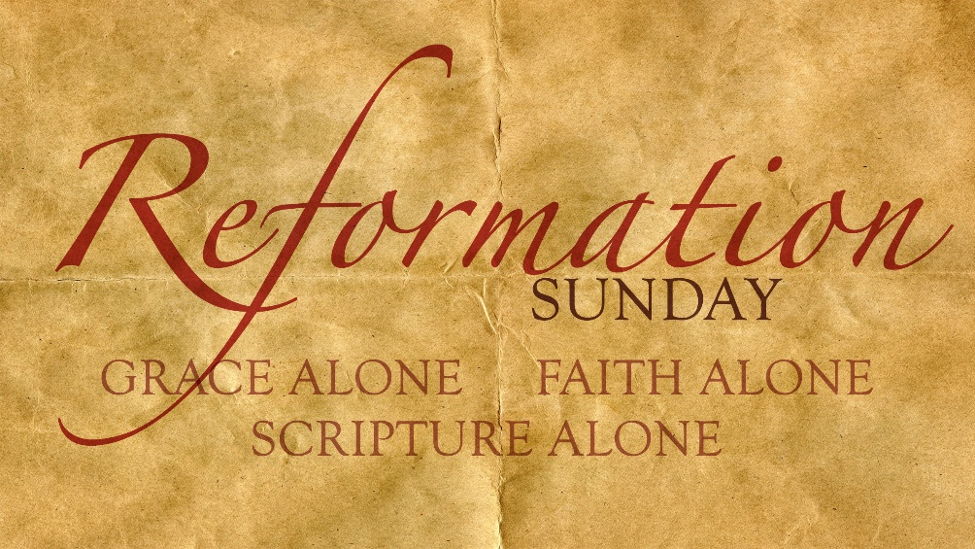

https://pccweb.ca/stpauls

Interim Moderator Rev. Robert Lyle 902-549-6411
Clerk of Session Jan Alchorn
Pianist Linda Giddens

ORDER OF WORSHIP
Call to Worship
The Lord has been our dwelling place in all generations.
From everlasting to everlasting, God is God; and so we come to worship.
God satisfies us every morning with steadfast love;
Let us rejoice and be glad all our days.
Tell of God’s glorious power and praise God’s holy name.
We will offer God the work of our hands and praise from the depths of our hearts.
Hymn 86 A mighty fortress is our God
Prayers of Adoration and Confession (in unison)
God, our God, You are gracious and loving, holy and eternal;
your love is steadfast, your presence ever near. Your wisdom is older than time and as fresh as the morning dew. Your name has come to us through the centuries, yet you can always do a new thing to draw us back to you. Holy God: Creator, Christ and Spirit, Three and One we offer you our prayers and praise this day in humble expectation; refresh our understanding and nurture our readiness to serve you. In recalling all that you have done and who you are, we recall who we have been and what we have done. Out of a desire to begin again with you and one another, we confess to you our sins:
Merciful God, you know our hearts, the times we truly loved one another and the times we merely tolerated each other. You know our minds the times we focused on you and the times we pursued our own purposes. You know our bodies, the times we have served you and the times we have served only ourselves. Forgive us those times we went our own way, and renew our commitment to live lives marked by your grace.
Assurance of Pardon
Friends in Christ, we are forgiven people, set free from past failures, to make a fresh start this day and every day. The Holy Spirit empowers us to love God and to love others. Thanks be to God for such everlasting grace!
WE HEAR GOD’S WORD
Old Testament Lesson Deuteronomy 34 p 151
Responsive Psalm 90:1-6, 13-17 p 424
N.T. Epistle Lesson 1 Thessalonians 2:1-8 p 835
N.T. Gospel Lesson Matthew 22:34-46 p 699
Hymn 8 God’s law is perfect
Sermon Commandments/The Great Commandment
OUR RESPONSE TO THE WORD
Hymn 307 The church’s one foundation
Offering and Offertory
Doxology (603)
Prayer of Dedication
Prayers of God’s People and The Lord’s Prayer
The Apostles’ Creed 616
WE GO OUT IN SERVICE
Hymn 291 Word of God, across the ages
Benediction & Choral Amen

****Please remember to put your clocks back next Sunday

Calendar of Services till the end of the year
Nov 1 – Brad Little All Saints Day
Nov 8 – Maryann Skinner Remembrance Service
Nov 15 – Bob Lyle Fellowship Sunday
Nov 22 – Brad Little Christ the King Sunday
Nov 29 – Maryann Skinner 1st Sunday of Advent - hope
Dec 6 - Bob Lyle 2nd Sunday of Advent – peace
Dec 13 - Brad Little 3rd Sunday of Advent – joy
Communion & Fellowship
Dec 20 - Maryann Skinner 4th Sunday of Advent – love
Dec 24 – Christmas Eve Service @ 4:00pm
Dec 27 - Bob Lyle 1st Sunday after Christmas

MISSION MOMENT: Sunday, October 25
In Mwanyesha, Malawi, Vincent Ng’ambi lives with his wife and five children. They previously struggled in a leaking thatched house and faced food shortages due to climate change, making farming unreliable. After joining the Lupembe food security project, they received training in climate-smart agriculture, self-help groups and household visioning. The training helped increase their maize production, enabling them to build a safe home. “We are grateful and proud. Thanks to household visioning, we dreamed bigger and set goals. Our new brick house with iron sheets symbolizes our hard work and a better future. We’ll live in it and finish with cement flooring and windows next year,” Vincent shared with tears. This project is an initiative of PWS&D’s partner, the Synod of Livingstonia Development Department.

