Private Devotion
&

Questions To Take With You

Here are a few points of reflection to take with you.

- When was the last time you “cast on the right side of the boat” and knew you had listened to God? How long has it been since you acted on what God was saying/telling? Why?
- When you are busy - in whatever keeps you busy - do you take enough time for rest? Do you ever, or often, encounter Christ there?
- It is nice to have a meal served to you, but what would you do if Christ himself showed up at your workplace, or home, in a lunch wagon/truck to serve you lunch? Can you think of times when Christ has done this through other people?
This is your time, and a grace from God.

Good Fishing, and God Bless

Passages For our Study

1. Meeting
A. Christ by the shoreline
John 21:6-14
B. The call to go fishing
Matthew 4:18-22 [Mark 1:16-20]
C. A meal of proof

Luke 24:42

2. Picking a spot
A. Fishing where you are told to fish
John 21:1-7
B. Living by the living water - The best spots
Ezekiel 47:8-11
C. The plague upon the water
Exodus 7: -25 [Psalm 105]

3. Casting Lines
A. Creation and Purpose
Genesis 1:26-31
B. Do unto others
Matthew 7:9-12 [Luke 11:11-13]
C. Catching & getting caught
Jeremiah 16:16-21

4. What to catch
A. The big catch; getting caught
Jonah 1-2:10
B. A catch that pays for the license
Matthew 17:27-
C. Fishing because of what you are called
Matthew 4:18-22 [Mark 1:16-20]

Fishers

of

Men

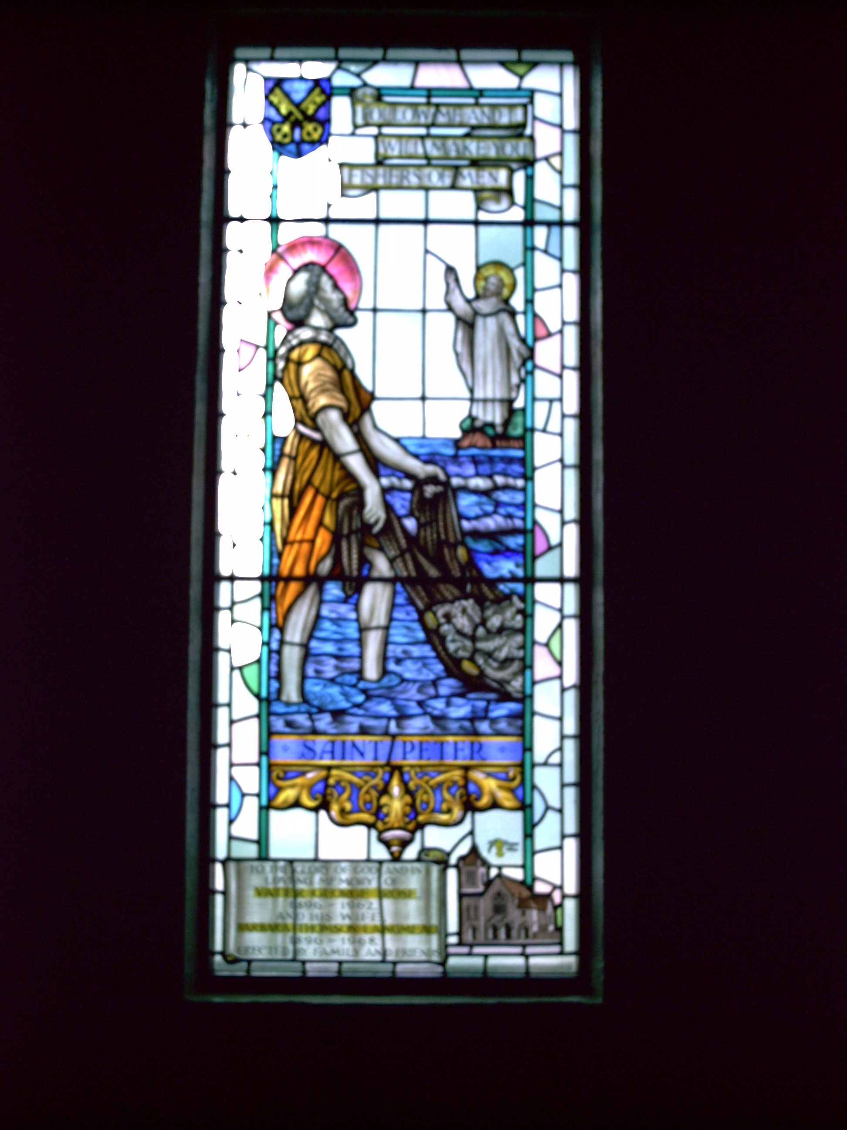
Study 1

Direction from the Shore

The disciples returned to the work that they had known before coming and following Jesus. Though they were taught to be fishers of men, after Jesus death and resurrection they went back to being fishing men.
But Jesus - raised from the dead - searched them out, waited by the water, and made them breakfast.
What is the significance of what Jesus did?

- He went to his disciples

- He helped them with their labour by telling them where to cast their nets

- He made them breakfast, and served them.

- He reassured their belief in his resurrection by appearing to them.

- (Your thoughts) ___________
________________________
________________________

John 21:6-14

⁶He said to them, “Cast the net on the right side of the boat, and you will find some.”
So they cast it, and now they were not able to haul it in, for the quantity of fish.
⁷That disciple whom Jesus loved said to Peter, “It is the Lord!” When Simon Peter heard that it was the Lord, he put on his clothes, for he was stripped for work, and sprang into the sea. ⁸But the other disciples came in the boat, dragging the net full of fish, for they were not far from the land, but about a hundred yards off.
⁹When they got out on land, they saw a charcoal fire there, with fish lying on it, and bread. ¹⁰Jesus said to them, “Bring some of the fish that you have just caught.” ¹¹So Simon Peter went aboard and hauled the net ashore, full of large fish, a hundred and fifty-three of them; and although there were so many, the net was not torn.
¹²Jesus said to them, “Come and have breakfast.” Now none of the disciples dared ask him, “Who are you?” They knew it was the Lord. ¹³Jesus came and took the bread and gave it to them, and so with the fish. ¹⁴This was now the third time that Jesus was revealed to the disciples after he was raised from the dead.
________________________________________________________________________________________________________________________________________

Looking & Doing

There are two disciples noted in this passage:
- The disciple who Jesus loved [assumed to be John]
- Simon, who was called Peter
John recognized Jesus for who he was. [It was not that John was the only disciple who did not need glasses.]
To understand John’s ability to recognize Jesus discuss how you see Jesus and recognize his presence in your life, in the lives of those around you. _________________________
_____________________________
Peter acted. He jumped from the boat and waded into shore. In most stories about Peter, he is the first one to react to what Jesus is doing and saying. Peter left the others to deal with the catch of fish, and rush to shore. Is there a time to set aside labours, even when things are going well, and run to Jesus? ___________
_____________________________
__________________________________________________________
_____________________________

