The Presbytery of Westminster met in Regular Session on Tuesday, May 4, 2021 at 7:00pm via Zoom Video Conferencing due to the Covid-19 restrictions on in-person meetings. Worship was led by Janet Eastwood, Savannah McIntyre, Cathleen Dennehy and Daniel Martinez, Camp Douglas Staff.

**CONSTITUTION**

The Moderator, Patricia Dutcher-Walls constituted the Court and opened the meeting with prayer at 7:38pm.

The Moderator welcomed the following guests:

Cathleen Dennehy, Savannah McIntyre and Janet Eastwood, Camp Douglas Staff.

Leave to withdraw: None

**DOCKET**

It was moved by Victor Kim seconded by Melanie Adams, that the consent agenda below be adopted.

**CARRIED**

**Consent Agenda**:

* that the Docket be as indicated,
* that the attendance be recorded as noted in the Roll Record Book,
* that regrets and requests for permission to withdraw be noted as sent to the clerk of presbytery,
* that the minutes of the regular meeting held on April 6, 2021 be adopted,
* that the correspondence be dealt with as indicated,
* that reports without recommendations be received “for information.”
* that reports with recommendations be received and their recommendations considered,
* that the presbytery treasurer be permitted to speak to financial issues.

If the Court is agreed, these motions will be adopted at the beginning of the meeting. Any member may ask for an issue on the consent agenda to be withdrawn from this list before the agenda is adopted.

**ROLL**

Constituent Roll:

M. Baxter, H. Botha, P. Dutcher-Walls, P. Eastwood, M. Fontaine, B. Fraser, S. Goble, G. Jay, V. Kim, R. Lockhart,

C. MacLeod, L. McKay, R. Simpson, B. Skelding, G. Snyman, M. Szigeti, R. Topping, W. van de Wall, R. Watson,

M. Wong, D. Woods

N. Abramson, M. Adams, B. Astop, A. Beattie, I. Evans, B. Feick, C. Gleimius, L. Gorman, L. Johnson, K. Kim,

K. Patrick, C. Rebosura (Alt for First), K. Sewell, B. Shepansky, G. Shields, J. Sonachansingh, S. Stacey, E. Wilson,

P. Wong, L. Yen, M. Zaine

Appendix:

L. Bae, B. Garvin, R. Ross

Students/Certified for Ordination:

D. Martinez, C. Lee

**REGRETS:**

B. Childs, T. Hsieh, W. van der Westhuizen, J. Con, D. Jennings, A. Lin, K. Jordan, A. Perrett

**CORRESPONDENCE:** March 29 – April 25, 2021

|  |  |  |  |
| --- | --- | --- | --- |
| 03-29-21 | Brad Childs | Commission to St John’s report to Presbytery | Received |
| 03-30-21 | Jennifer Astop | Funds designated for Indigenous Ministry (Hummingbird) | Received |
| 03-30-21 | Larry Eastwood | RRG funds have been received and will be dispersed shortly. | Noted |
| 03-31-21 | Paddy Eastwood | Adding members to the Student Support and Certification Team | Received |
| 04-01-21 | Jacqueline Chartier | Formal letter from St. John’s requesting assistance from Presbytery to appoint two Assessor Elders | Received |
| 04-02-21 | Laurie Trulson | Submission of Coquitlam PC 2020 Statistical Reports | Received |
| 04-03-21 | Pam Wong | Submission of Brentwood PC 2020 Statistical Reports | Received |
| 04-06-21 | David Jennings | GAI – request to reconsider - additional comments | Received |
| 04-06-21 | Ron Miller | Sending regrets for April 6 presbytery meeting and advising that he is transferring his membership to St. Aidan’s therefore cannot be Rep elder for First PC | Noted |
| 04-06-21 | Claudine Rebosura | Will attend April 6 presbytery meeting in place of Ron Miller | Noted |
| 04-06-21 | Miklos Szigeti | Requesting reference letter as church in good standing within the PCC for renovation funds through the Hungarian Diaspora Fund | Received and responded |
| 04-07-21 | Marjorie Copeland | Presbytery Statistical Information for the 2021 A&P | Received and responded |
| 04-07-21 | Marjorie Copeland | Degree information update form | Received and responded |
| 04-07-21 | Glen Davis | Requesting clerk to send application to Cooke’s Fund for Shepherd’s House. Documentation attached for forwarding | Noted and responded |
| 04-07-21 | David Jennings | Requesting his request for presbytery to reconsider the GAI recommendation be provided to presbyters directly. | Distributed |
| 04-07-21 | Willem van der Westhuizen | Requesting wording of the Commission Report recommendation so that it can be forwarded to congregation | Received and responded |
| 04-07-21 | Melanie Adams | Submission of Knox 2020 Statistical Report | Received |
| 04-08-21 | Claudine Rebosura | New rep elder will be determined at next meeting of session for First PC | Noted |
| 04-08-21 | Clara Choi | Shepherd’s House Cooke’s Grant application question | Received and responded |
| 04-09-21 | Brian Fraser | Apology from Johnathan Kwon was accepted by the Presbytery of Assiniboia | Received |
| 04-09-21 | Arthur Lin | Submission of BTPC 2020 Statistical Report | Received |
| 04-10-21 | Larry Eastwood | 2021 Accepted Presbyterians Sharing Allocations | Received |
| 04-10-21 | Ta Li Hsieh | Moltmann’s 95th Birthday - free download of his book “Hope in these troubled times” for one week only until April 15 | Distributed |
| 04-10-21 | Larry Eastwood | Addition to the Presbyterians Sharing for West Point Grey | Noted |
| 04-12-21 | Kathryn Muir | Changes to the Roll – March 2021 | Received |
| 04-12-21 | Dale Woods | Reminder about April 17 workshop – Better with Brunch. | Distributed |
| 04-12-21 | Maggie Leung | POW 2021 Accepted Presbyterians Sharing allocations, recorded differences | Received |
| 04-12-21 | Johanna Jansen | Submission of St. Andrew’s Newton 2020 Statistical reports | Received |
| 04-12-21 | Mary Fontaine | Requesting POW endorsement for HB grant applications | Received and responded |
| 04-12-21 | Ta Li Hsieh | Submission of ‘degrees’ list for PCC | Received and forwarded to K. Muir |
| 04-13-21 | Gordon Shields | Request for study leave for Rev. Paddy Eastwood for June 5-16 | Received and forwarded to Ministry Committee |
| 04-13-21 | Larry Eastwood | POW Financial Statements for March 2021 | Received |
| 04-14-21 | Mary Fontaine | Appreciation for endorsements for grant applications | Noted |
| 04-14-21 | Janet Holman | Submission of Calvin PC 2020 Statistical Reports (amended) | Received |
| 04-14-21 | Paddy Eastwood | Requesting visitation report for St. John’s from 2014-2017 | Received and responded |
| 04-15-21 | Bev Feick | Submission of Langley’s 2020 Statistical Report | Received |
| 04-17-21 | Judy Sonachansingh | Facebook Page and disrespectful post with PCC ties | Received and forwarded to Admin Committee |
| 04-21-21 | David Jennings | RE: Letter from Bosa on Central PC GST payment - looking for update | Received |
| 04-21-21 | David Jennings | Presbyterian Extension Fund | Received |
| 04-21-21 | Ian Rokeby | Additional signing officer for release from VCPC escrow account should be added | Received |
| 04-22-21 | Daniel Martinez | Camp Douglas Spring Letter and Camp Dates | Received and circulated |
| 04-22-21 | Kathryn Muir | Forwarding an updated address for Rev. Laszlo Szamoskozi | Received |
| 04-23-21 | Cal MacLeod | Memorial Minute for Zena MacKay | Received |
| 04-26-21 | Richard Topping | Research Link regarding church and covid stats from Angus Reid | Admin Committee |
| 04-26-21 | Paddy Eastwood | Committee restructuring in view of priorities | Admin Committee |

**COMMISSIONING OF CAMP DOUGLAST STAFF**

The Moderator commissioned the staff of Camp Douglas that were present at the meeting.

Camp Douglas staff were given permission to leave the meeting.

**Fifteen minute Breakout Groups for Fellowship and Prayer time was recognized and greatly appreciated.**

**REPORTS**

**STRATEGY AND LEADERSHIP COMMITTEE REPORT**

*The report was presented by Rebecca Simpson, Strategy and Leadership Committee Convener.*

*All motions, unless otherwise noted, moved by Rebecca Simpson, seconded by Susan Stacey.*

**Strategy and Leadership Committee**

**Presbytery Report - May 4, 2021**

Two applications to the New Witnessing Communities funding were received by the SLC in April. The SLC met at its earliest opportunity on April 20 to consider the applications and other urgent presbytery matters. Further deliberation on the applications took place at an SLC meeting on April 29. It was determined that both applications were creative and hold potential for innovative ministry, but neither application sufficiently demonstrated financial sustainability, especially in the medium term. Both applicants have been informed of this and that there will be another date to receive updated applications in the fall of 2021.

It has also come to light that with the newly understood financial picture at Central PC, the presbytery will need to reconsider its strategy for securing funding for the New Witnessing Communities grants. While the congregation of West Point Grey PC welcomes the use of their property as collateral for the loan that would fund the NWC grants, the bank would also require a demonstration of adequate cash flow to pay back the substantial loan. The dire financial situation at Central PC puts into question whether our presbytery would be able to demonstrate adequate cash flow for such a loan. The Property and Finance subcommittee and Strategy and Leadership committee will be working on this issue in the coming weeks.

The good work of the PMV brought us a presbytery exploration of how Cascadian congregations are innovating in “Better Than Brunch” by Rev. Dr. Ross Lockhart and Rev. Dr. Jason Byassee on Saturday April 17. Dale continues to work with Camp Douglas on their mission and vision discernment and with the “Growing Together” churches on their visioning process. All five sessions with the “Growing Together” churches have now been completed and a summary report is being drafted for the congregations. The PMV has conducted an initial strategic planning session with Hummingbird Ministries. As requested by the presbytery, the PMV has been in touch with St. John’s White Rock to begin planning stages for moving forward in that congregation. Finally, the PMV continues to work with interim moderators. The video of the “Better Than Brunch” workshop is now available on the presbytery website and the next Coffee and Conversation will take place on May 20, 9:30-10:45 as a follow up to the workshop. Contact Dale Woods to register, pmvwestmin@gmail.com.

The SLC convener worked closely with Interim Moderators, Ross Lockhart and Richard Topping, as Central PC presented their drastically reduced 2021 budget to the congregation. The Central PC financial report produced by the Property and Finance sub-committee, as presented to the Central session and congregation in April, is attached here as Appendix A. This report makes clear that financially Central PC is unable to support the full expenses of their building, and they do not have the financial capacity to provide for a minister or any paid staff. On top of all of this, the GST issue has become more urgent in the last month and so the following recommendations are before the court:

***Recommendation 1:***  Whereas Central PC was presented with an outstanding legal obligation to pay $950,000 in GST due to CRA, and the project partner, Bosa Properties, is currently demanding that payment be made, and whereas Central PC has requested Presbytery’s help in addressing this obligation, be it resolved:

That a Task Force be sent to Central PC, Vancouver with a specific mandate to help the congregation assess its short- and long-term financial difficulties. The Task Force should present at least an interim report to the Presbytery by June 2021, with appropriate follow up report(s) no later than November 2021. Given the Presbytery’s fiduciary responsibility to protect the assets of the PCC, the mandate of the Task Force is to arrange the best possible solution to preserve the possibility of Christian ministry in that location and to preserve the real estate assets for ministry. The task force be given power to issue to negotiate contractual arrangements for financial accommodation, subject to approval by Presbytery. The Task Force will include 3 – 4 people to be named by the Moderator, to include members of the Strategy and Leadership Committee and its Property and Finance subcommittee. **CARRIED**

***Recommendation 2:***  That Presbytery gives permission to pay outstanding legal fees, approximately $30,000, on behalf of Central PC, Vancouver, and that such an amount will be a liability of Central PC to Presbytery. **CARRIED**

**Property & Finance sub-committee highlights:**

P&F met April 21, 2021.

• Central Church: P&F reviewed work done by chair and Presbytery Treasurer in assessing CPC finances and making recommendations regarding 2021 budget (now passed) and other financial measures needed to address challenges faced by this congregation.

• St. John’s White Rock: email correspondence was received from SJWR regarding support in pursuit of a possible real estate redevelopment initiative. At the suggestion of the Moderator, P&F has advised them that engaging on this issue should be deferred until after the completion of the work of the Presbytery Visitation Team has been completed.

• Brentwood Church: BPC is advancing through their next phase study on possible facility expansion, and are seeking clarity on the due diligence and oversight that Presbytery will apply to any future initiative in this regard (see Check-List item below).

• Development Planning Check-List: P&F discussed providing a standardized check-list of due diligence measures to be required of any congregation proposing expansion or redevelopment of their built infrastructure, given that this is being pursued by an increasing number of our congregations. The committee will work to adapt guidance previously provided to VCPC to make it more general and adaptable to a wider range of situations as an initial draft.

• Template Rental Contracts: This initiative, aimed at providing template contracts to congregations covering the most common forms of facility rental to outside groups, will be initiated in the coming months. David Jennings has an “interim” document should congregations need something in the next few months.

*Joyfully Submitted*

*Ian Rokeby*

*Chair*

**6 Month Review of The Rev. Dr. Dale Woods**

**Presbyter for Mission and Vision in the Presbytery of Westminster**

The Strategy and Leadership Committee undertook a preliminary 6 month review of Dale Woods as the PMV for the presbytery as mandated in the terms for the position of the PMV. Given that this is a 6 month review and given the extraordinary circumstances under which this position was initiated, both of a global pandemic and the fact that this position is unique within our denomination, it was felt that the SLC would provide a brief review at this point and that a more detailed review would be done at the 1 year mark of the ministry.

As members of the Strategy and Leadership Committee, who have worked closely with the PMV and through whom the PMV reports to presbytery, we feel we can speak with some authority on how Dale has performed over the first 6 months of his ministry as the PMV.

Some salient points:

* The hiring of Dale Woods as PMV was critical to the potential of the PMV position as he brings credibility, capability and capacity to the position. Dale brings a strong combination of gifts to the PMV position and has engaged those gifts quickly upon starting his position. He has made contact and initiated relationships with each congregation and the specialized ministries, Camp Douglas and Hummingbird Ministries, within the presbytery.
* Dale’s work with the Collaborating Churches has been much appreciated and his leadership in guiding the SLC through the process of creating the terms of reference for the application for New Witnessing Communities has been crucial for the presbytery.
* Dale has also begun the work of providing a framework to help existing congregations work towards transformation. A document, ***“Seeking Transformation”*** has been produced as a first step for those congregations interested in this process.
* Clearly, Covid-19 and the pandemic has limited the ability for Dale to connect with presbyters and congregations. The need to visit on site and be involved in face-to-face conversations cannot be overstated for a position such as the PMV. Given the inability for Dale to generally follow up in these matters, it is unsurprising that any review of both Dale and the PMV position must be understood as incomplete.
* The temptation remains for the presbytery and the SLC to see Dale and the position of the PMV as a bit of a “Jack of All Trades,” easy to slot into every crisis that comes up. While Dale has done admirably where he has been asked to serve and lead, the SLC remains committed to not over-extending the PMV and reserving capacity for Dale to play a pivotal role in leading the transformation of the presbytery as per the short terms goals that have been identified.
* The workshops that have been led by and facilitated by the PMV have been greatly appreciated by those in attendance. It will be important to make sure that the workshops, while offered as learning opportunities for the community, can also identify what particular outcomes are desired through the offering of the workshops.
* Dale’s non-anxious presence has been appreciated by those with whom he has interacted and worked. His own sense of comfort leads others to feel comfortable working with Dale and engaging with his leadership. Dale has consistently communicated effectively and thoroughly with the SLC and through the SLC, with the presbytery.
* Dale has provided a detailed account of his time in the position of PMV which aligns his work with the stated vision of the presbytery. It is clear that Dale has engaged strategically and intentionally with presbyters, congregations and ministries during his first 6 months as the PMV. An updated version of this document that would align with 1 year review will be shared with the presbytery.
* Dale’s own assessment is comparable with the assessment of the SLC and acknowledges the limitations of the pandemic and the unique nature of this position. He also recognizes the danger of taking on too much and the importance of a balanced workload.

Overall, the SLC is very pleased with how Dale has begun his ministry as the PMV for our presbytery. We believe that his gifts and presence have been a substantial gift to our presbytery and look forward to the work and ministry that Dale will continue to bring as the PMV for our presbytery going forward.

*Respectfully submitted,*

*Rebecca Simpson, Convener of Strategy and Leadership Cte*

**Appendix A**

**Central Presbyterian Church**

**Report to SLC: Budget Recommendations**

March 28, 2021

This report provides a preliminary draft set of budget recommendations for Central Presbyterian Church, taking into account their present financial situation. It is intended that a budget along the lines of that indicated below be presented to the congregation at the first opportunity for consideration.

**Background:** Presbytery Property and Finance Committee (P&F) has been asked to review the finances of Central Presbyterian Church (CPC) and provide recommendations concerning establishing a suitable congregational budget for 2021. This task has been undertaken against the background of the previous request from CPC to Presbytery, namely for support in obtaining a loan of approximately $950,000 in order to satisfy obligations created under the congregation’s agreement with Bosa (developer of the new CPC complex). This GST became payable upon transfer of the congregation’s interests in the building back to CPC following construction. Approximately half of this amount will ultimately be refunded to CPC in time. This latter issue remains unresolved at present, although establishing a workable congregational budget is clearly a key consideration in determining whether further financing can be arranged for the congregation.

A key feature of CPC’s finances is their relationship with Bosa and with two other “units” under the control of the congregation, as follows:

* The CPC Foundation, which holds a retail space in the new CPC complex (Air Space Parcel 1, or “ASP1); and,
* The Housing Society, which holds and, through a contract with McDonald Realty, operates a multi-unit, low-rent housing complex (Air Space Parcel 3, or “ASP3”).

These two units, together with the congregation’s church space (ASP2) present a number of special considerations relating to the congregation’s finances and the structuring of an appropriate budget. Chief among these are the following:

* Bosa controls the timing of anticipated future capital replacement expenditures which will be needed to maintain the integrity of the building over time. Under the terms of the agreement, CPC is obligated to fund the CPC share of required capital replacement expenditures when called upon by Bosa. Failure to do so would constitute default by CPC under the agreement with Bosa, and result in [control of the real estate assets passing to Bosa—TBC]. A comprehensive 40 year forecast of these expenditures was prepared by Morrison Hershfield (MH). This included recommendations for the establishment by the congregation of a Capital Replacement Fund (“CRF”) in which funds would accrue over time to allow CPC to meet future demands for capital replacement expenditures. To date, no CRF has been established, and no contributions have been set aside.
* ASP1 and ASP3 represent distinct units of real estate unrelated to CPC’s mandate, and are in the process of being configured as distinct entities with separate control. To date, the net proceeds of ASP3 have been comingled with those of the church, with monthly net ASP3 revenue being transferred to CPC’s accounts on an ongoing basis. These funds have been utilized to satisfy CPC operating expenses, and at the time of writing there is no significant fund balance in either CPC or ASP3. ASP1 has remained vacant until late 2020, at which time a new commercial venture entered into a lease with the CPC Foundation, which included a number of months of free rent. This period has now come to an end, and ASP3 will now begin generating approximately $100,000 per annum in net contribution. This is approximately equal to the planned contributions to the CRF for ASP3.

**Objectives:**  The objective of the current work and this report has been ensure adequate operating cash to allow time to take appropriate steps to address CPC’s financial situation, and in support of that, to synthesize a comprehensive understanding of CPC’s structural deficit and the CRF situation sufficient to prepare recommendations for a 2021 congregational budget. At a future date, all of this information will need to be revisited as Presbytery addresses CPC’s request for assistance in obtaining a loan to deal with their unfunded GST obligations.

**Analysis Undertaken:** In seeking to assist CPC in preparing an appropriate budget, P&F identified five key tasks necessary given the complexity of the finances of the congregation, as follows:

* **Structural Deficit**

Given the total net revenue potential of ASP1, the congregation, and ASP3 from all sources, as well as the size of the CRF capital needs (not yet addressed), P&F set out to determine the inherent deficit or surplus in a scenario where the full planned contributions to the CRF were achieved.

* **2021 Budget Recommendations:** With a clear understanding of the structural deficit (if any) P&F is undertaking to formulate recommendations for a workable budget for 2021, to be adopted at the first opportunity. This task is the primary focus of this report.
* **Operating Cash for 2021:**  P&F became aware in the course of our work that the cash reserves in the congregation are very low. P&F undertook to confirm how much cash would become available in future periods to ensure that there was adequate time to consider the totality of CPC finances and prepare comprehensive recommendations, ultimately including consideration of the CPC request for Presbytery support for a loan to deal with the GST issue. It has now been confirmed that, as an interim measure, the flowing through of ASP1 and ASP3 revenues, together with revenue from church facility rentals and offerings will allow the church to continue meeting its obligations for a time, providing that CRF contributions remain below the level intended. Thus, it is suggested that Presbytery should target coming to a conclusion on CPC’s loan request and any other actions regarding CPC finances, not later than the third quarter, 2021.
* **CRF and Retaining Control of the Building:** Continuing to operate without funding the CRF as originally planned will ultimately result in loss of the building under the terms of the Development Agreement with Bosa. Thus it is imperative that a plan to make CRF contributions be made as soon as possible, and that if these cannot be accommodated to the level required in the MH analysis, that further analysis carried out to confirm the reduction in congregational tenure in the building that will result. Once initiated, CRF contributions need to be treated as a fixed cost (possibly by transfer to Presbytery on a regular basis). The time frame of CPC’s tenure in their building will be determined by their ability to make substantive contributions to the CRF. In assessing the Structural Deficit, P&F has come to preliminary recommendations relating to this issue.
* **Confirming Use Of 2019 And 2020 ASP3 Net Revenue:** Through investigation, it has become apparent that to the extent that CPC generated an operating deficit during 2019 and 2020, this was satisfied by redirecting funds originally intended for the CRF to provide for ongoing congregational operating expenses. This is notable, particularly given that CPC did not have a minister during 2020.

**Meeting Dates:** The complexity of CPC finances and the challenges presented by their current situation have taken substantial effort to review and analyze. To date, in addition to P&F’s regular March 10 meeting, the Presbytery Treasurer and P&F chair have met variously with each other, with CPC leaders, and with SLC chair Rebecca Simpson on the following dates:

* Feb 17, 24; March 20, 24, 25, and 30.

**Observations:**

The following observations are offered regarding the current state of finances of CPC:

The following observations are offered regarding the current state of finances of CPC:

* CPC congregational operating expenses, even without a minister, substantially exceed the   conventional revenue sources of the CPC Foundation, Housing Society and congregation, leaving it with a structural operating deficit of approximately $298,000 even without any congregational CRF contribution. This means that without additional sources of revenue, CPC would realize a deficit of approximately $298,000 each year, even while vacant, based upon current patterns of giving, facility rentals, and expenditures and would not have any significant funds to make capital cost payments to Bosa for building capital replacement requirements.
* CPC have funded ongoing operating deficits by comingling net proceeds of the Housing Trust (to be established) on an ongoing basis. It is believed that to date this has been approximately $500,000 over the course of 2019 and 2020.
* Despite the use of the Housing Trust net revenue to fund congregational expenditures, there is no significant reserve fund associated with the congregation, ASP1, or ASP3. There are modest reserves in the form of approximately $20,000 in GIC’s, which would not be sufficient to weather any significant adverse financial development.
* The lack of contributions to the CRF to date is a source of concern which, left uncorrected, will ultimately result in the loss of the congregation’s real estate assets. Total CRF contributions to the end of 2020, net of facility operating costs, were planned to be $225,918 from all sources, but these funds were instead used to fund church operating expenses. Preliminary assessment of the effect of these “missed” contributions, if dealt with within the next few years, suggests that the CRF will still be sufficient to meet capital replacement spending needs through approximately 2057, at which time there would be a deficit; this would still allow time for the congregation to develop new ministry and funding initiatives which might serve to address this at that time.
* Significant congregational operating cost reduction is necessary to allow for some contributions to the CRF and to address the cost of the GST loan, if approved. These changes will take time to achieve. For planning purposes, P&F’s recommendations have staged these over 2 years, recognizing that some contracts cannot readily be renegotiated.
* Without significant cost reductions (and corresponding reduction in the grant from the housing trust) , it will not be possible to fund needed CRF contributions or retirement of the anticipated GST loan. In this circumstance, Presbytery would be unable to achieve support for a third party loan to finance the CPC GST issue.
* Introduction of a GST loan creates a strategic challenge for CPC. Specifically, it is necessary to balance disbursements between congregational operating costs and ministry; CRF contributions needed to protect the building; and debt servicing on the needed GST loan. Addressing this situation requires a carefully crafted, multi-year approach to budgeting and financial management. P&F have analyzed a scenario which could form the basis of a budget recommendation. It includes:
  + Introduction and accelerated repayment of a GST loan (retired over 4 years),
  + Two-year staged program of expense reductions,
  + No minister,
  + Return to scheduled CRF contributions upon retirement of the GST loan in mid-2024;

The resulting CRF balances appear to be sufficient to address capital replacement needs through 2056/2057, providing ample time to clarify the future ministry model and revenue potential of the congregation.

**Proposed Budget Principles:**

The following principles are proposed to be applied in formulating a budget for CPC for 2021:

* All Expenses to be minimized and contracted services be discontinued/reconfigured wherever possible, to be addressed over a two-year period;
* Remaining Honoraria are to be broken down and itemized (pulpit, guest musicians, administration, if any, other), and minimized;
* Exclude provision for search process or hiring a minister; and,
* Exclude legal expenses budget for 2021 (remaining payables and reasonable provision for trust finalization and/or other necessary to restructuring to be financed from Presbytery held CRF funds (consult D Jennings, Miller Thomson)
* Include provision for six months interest on the GST Loan in 2021 (estimated at $11,500), with congregational spending arranged to prioritize GST Loan repayment for 2021 through 2024, then reverting to full planned CRF contributions;
* Revenue from all sources is to be documented, and managed to provide a $150k annual “grant” to CPC in order to balance the CPC budget; remaining ASP1 and ASP3 net proceeds to flow to Presbytery for debt service (and later CRF contributions)
* Following retirement of the GST loan (estimated mid-2024), surplus funds to be redirected to CRF and in following years to provide, at a minimum, the previously planned CRF contribution ($227,331 in 2025).

**Proposed Draft Budget**

The spreadsheet below is presented as a first draft congregational budget. It will require further adjustments to reflect specifics of the congregation’s situation not known to P&F, which in all cases need to be consistent with the budget principles outlined above.



**Other Issues:**

* **Spending Management/Cost Reduction:**  It is recognized that the recommended budget presented above reflects a very austere level of expenditure which will require the restructuring of every aspect of congregational ministry. This will not be pleasant. The understandable tendency of the congregation to resist this level of spending reduction must be balanced against the need to begin serious contributions to the CRF if the future of the congregation’s real estate is to be secured. Beyond the budget document itself, a significant level of discipline and diligence in implementing the recommendations of this report will be required to ensure the planned expenditure levels are actually achieved.
* **GST and Request for Loan:** This report is not intended to deal extensively with the subject of the request for a loan to CPC to assist it in discharging its GST obligations. However, this topic must be addressed soon. The ability to achieve third party financial support for CPC in this matter will be heavily dependent on the demonstrated diligence of the congregation in adopting and carrying out a budget along the lines described above. If Presbytery is not able to demonstrate a recovery plan for the congregation which addresses the structural deficit, then it is anticipated that commercial banks will be disinclined to approve a loan request.
* **Bookkeeping and Reporting:** The complexity of CPC’s finances, together with the importance of carrying out an ambitious cost reduction plan would be very challenging to any church treasurer. P&F observed that CPC has disaggregated the financial management of the congregation, ASP1, and ASP3 for ease of administration. This has the unfortunate side-effect of rendering the overall financial situation invisible to any individual or group without significant investigation. P&F recommends that a more integrated and transparent system of book-keeping and financial management be put in place to ensure that system-wide financial outcomes can be monitored and adjusted in real time.
* **Transfer of Assets to Trust:** On the assumption that the other recommendations of this report are carried out, it is important that the separation of the housing society assets in particular as originally planned with legal counsel, be carried out, in order to protect CPC’s charitable status.

**Conclusion:** A draft set of recommendations is presented, which, if embraced and implemented with diligence, can provide for an extended period of continued, if reduced, ministry for CPC. The challenges facing this congregation are substantial, and Presbytery will need to be satisfied that the congregation is prepared to implement disciplined spending management before it will be possible to pursue third party financing to address the CPC GST issue.

**COMMUNITY ENGAGEMENT COMMITTEE REPORT**

*The report was presented by Neil Abramson, Community Engagement Co-Convener.*

*All motions, unless otherwise noted, moved by Neil Abramson, seconded by Isabel Evans.*

Community Engagement Committee (CEC) Report to Presbytery

May 4, 2021

**PIM Grant Application**

The CEC reviewed an application from Dr. Anne-Marie Ellithorpe for a Friendship and Community Research Project and, as a result of an email vote, we recommend as follows:

**Recommendation 1:** That presbytery endorse the application from Dr. Ellithorpe for a PIM grant for her Friendship and Community Research Project. **CARRIED**

**Response to the BC Government’s comprehensive report on a Guaranteed Annual Income**

Following the distribution of this government report to presbyters, at the request of David Jennings, the CEC prepared a response to the report and had it circulated to presbyters for their information.

*Respectfully submitted,*

*Glen Davis – Co-convenor*

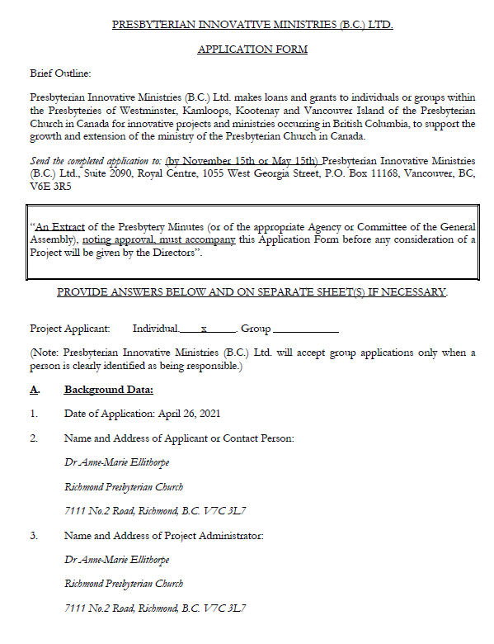

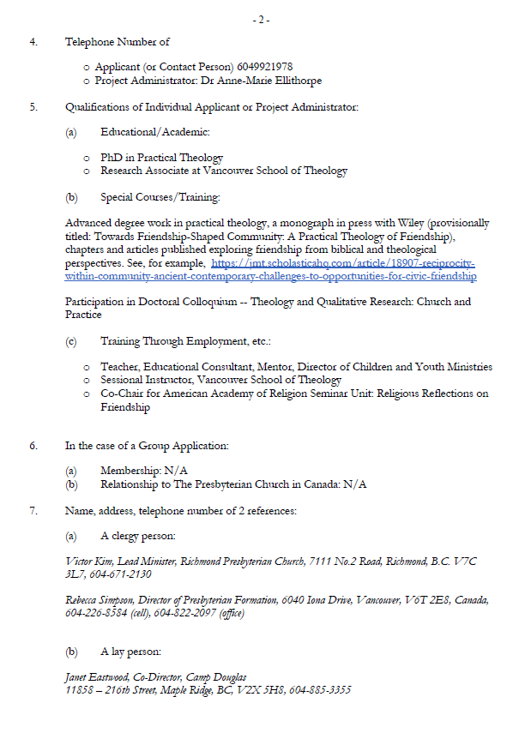

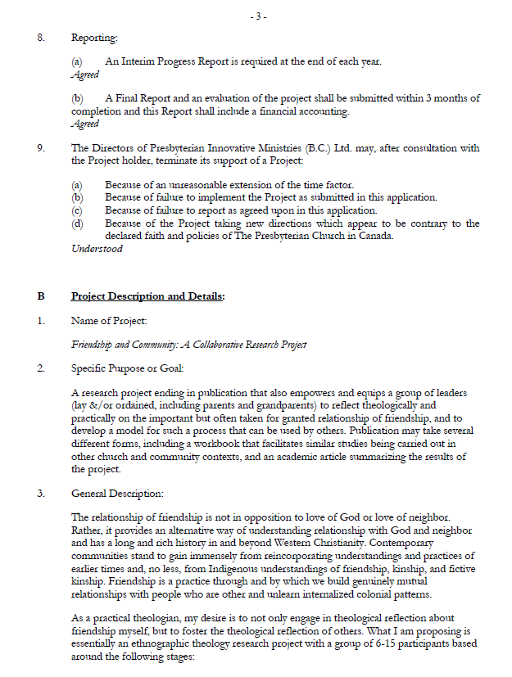

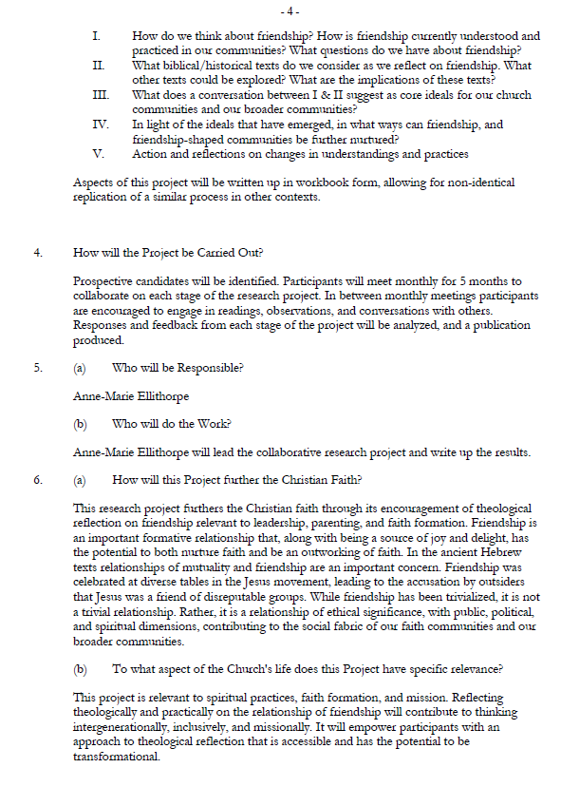

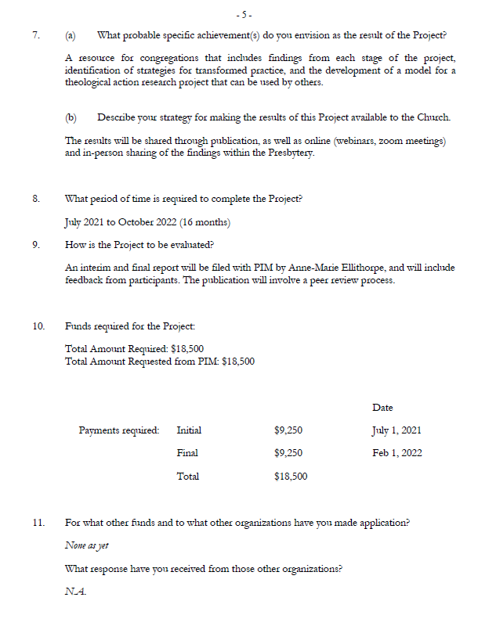

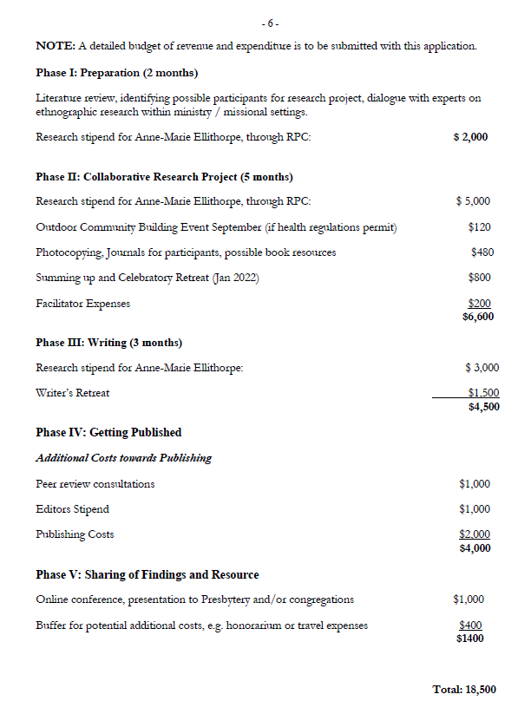

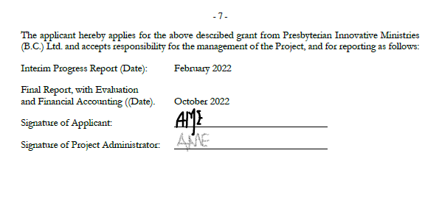

**HUMMINGBIRD MINISTRIES COUNCIL REPORT**

*The report was presented by Isabel Evans, Community Engagement Convener.*

*All motions, unless otherwise noted, moved by Isabel Evans, seconded by Laurie McKay.*

May 2021 Hummingbird Ministries Council Report to Presbytery

**Providing Opportunities for Healing and Reconciliation**

**Through Circles and the Arts**

**To restore Hope, Freedom and Justice**

**In Indigenous/Settler healing – Socially, Politically and Spiritually.**

Hummingbird Ministries (HM) Council met with Rev. Dr. Dale Woods on April 23, 2021 for our strategic planning meeting. The three hour Zoom meeting passed quickly under Dale’s leadership and guidance. We discussed the purpose, values and blessings of the HM. We also discussed the challenges that are faced by HM. At the close of the meeting we decided to review our conversation, brainstorm challenges and think about what we can work on in the coming year.

As with most other ministries, many of our plans were cancelled or postponed, although some of the outreach work to the families and especially the children continued.

HM received a letter from Jennifer Astop (Canadian Ministries Grant Program Coordinator) inviting HM to apply for $67,000 from the Specialised Ministries Fund for 2022. The deadline for applying for this grant is October 2021. Therefore:-

**Recommendation #1:** that Presbytery approve Hummingbird Ministries may submit a grant application in the amount of $67,000 from Canadian Ministries Specialised Ministries fund before October 1, 2021.

**CARRIED**

*Respectfully submitted,*

*Isabel Evans*

**ADMINISTRATIVE COMMITTEE REPORT**

*The report was presented Victor Kim, Administrative Committee Convener.*

*All motions, unless otherwise noted, moved by Victor Kim, seconded by Paddy Eastwood.*

**Administrative Committee Report – May 4, 2021**

**Induction Service for Richard Watson at Kerrisdale**

The date for the Induction Service for Rev. Richard Watson at Kerrisdale Presbyterian Church has been confirmed for May 16. It will be a 1pm Zoom service for most, if not all, participants. A zoom link will be sent to presbyters for this service. The presbytery will need to gather prior to the worship service, so a start time of 12:45pm is proposed.

**Concern regarding Facebook Group page**

The Committee considered correspondence received from the Session of St. Columba expressing their concern regarding a Facebook page that hosts a conversation group consisting of people associated with the Presbyterian Church in Canada. The name of the group is, “A Gathering Place, for members and friends of the Presbyterian Church in Canada.” The Session of St. Columba note that some of the posts are offensive and hurtful for many people. However, the Facebook page in question is not an official page of the PCC and is not administered by PCC staff. It is a page run by volunteers and many of the members of the page are associated with the PCC as clergy and lay people. The problem is that the Facebook page clearly states its connection with the Presbyterian Church in Canada and many of those who visit the page will not be able to differentiate the page from an official page of the PCC. One of the Administrators of the page is the Rev. Wendy Adams, a colleague within our Synod. The Admin Committee recommends that the presbytery contact Rev. Adams and request that she and the other administrators of the page in question consider removing the obvious references to the Presbyterian Church in Canada on their Facebook page.

**Recommendation 1:** That the presbytery write to the Rev. Wendy Adams and request that she and the other Administrators of the website, https://www.facebook.com/groups/2346973826 consider removing the obvious references to the PCC on their site.

**CARRIED**

**Memorial Minute for Zena Mackay**

A Memorial Minute for Zena Mackay who was designated as a Diaconal Minister within the Presbyterian Church in Canada is presented for approval and forwarding to the General Assembly Office.

**Recommendation 2:** That the presbytery adopt the following Memorial Minute for Zena MacKay and forward it to the General Assembly Office. **CARRIED**

Zena Elizabeth Mackay (Cavana)

March 24, 1923 – January 31, 2021

Zena’s parents immigrated to Canada with two (2) children, settling in Calgary where she was born. She was much younger than her siblings (14 years younger) and then at the age of 7, Zena’s mother died. All the other children had moved out of the family home and her father felt that it would be best for her to be looked after by her grandfather in Prince Albert. Her dad worked on the trains in Alberta and his run was from Calgary to Prince Albert. Zena always gave credit to her father for the influence he had on her and in her faith development.

Upon graduating from high school, Zena attended Ewart College with hopes to become a missionary, but life entered the picture and a mission was out of the question. She was designated in 1945 as a member of the Order of Diaconal Ministers. She travelled to Victoria and stayed with her older sister and attended Normal School to become a teacher. She taught in Prince George and that is where she met her husband. They honeymooned in Vancouver, never to return to Prince George. Zena did a little substitute and assistant teaching, but raising seven (7) children was a full-time job.

Her Christian faith was always a huge part of her life in whatever Presbyterian church she attended. She was an active member of the WMS and worked diligently behind the scenes of many WMS activities. She has been described as an effective worship leader and a dedicated friend. For the past 40 plus years Zena attended Gordon and in that time; she taught Sunday school and served as its superintendent.

Because of the gifts that God gave to Zena, the members of Gordon recognized these gifts, asked her if she would let her name stand for the eldership and was elected. In her time on the Session, she chaired the Worship and Mission committees.

Zena recognized that sometimes members of the church were not being kept up to date with the happenings at the church and suggested that a monthly newsletter be re-established. She became the Gordon Globe’s first editor. It is only recently that Zena retired from editing the Globe. Her humour, her editorials and the Secret Society of Seagulls are deeply missed by many long-time Gordon members.

Gordon Presbyterian Church was a very prominent part of her life and brought her much joy. She had a special friendship with all her church family. It was with sadness that the members of Gordon were informed of Zena’s passing, but we know she has gone to be with her Lord, Jesus the Christ, and for that we are truly grateful.

Zena MacKay - well done good and faithful servant.

**Review of Standing Orders and Committee Structure**

The presbytery is reminded that we had decided to commence a review of the current Standing Orders, including Presbytery Committee Structure and Responsibilities, in June of this year. We recognize the challenges of the pandemic to a full evaluation of the new committee structures and Standing Orders. However, to start the process, the following motion is offered:

**Recommendation 3:** That every Presbytery Committee and Specialized Ministry accomplish an evaluation of its work this past year using the following four criteria and report to the June presbytery meeting:

1. To what extent does the actual work of the committee this past year correspond to the Standing Orders description of the committee’s tasks. Does anything need to be changed in the Standing Orders?
2. To what extent are the Presbytery priorities being engaged and enacted by the committee? What improvements could be made in that effort?
3. How well is the mandate of the committee working? Are any changes needed in how the work of the committee is accomplished?
4. Is anything being missed by work of the committee that should be accomplished?

**CARRIED**

**Information about Covid and the Church**

The Rev. Dr. Richard Topping has shared the following link regarding work done by Angus Reid on Covid and the Church. We share this for the information of presbyters. https://angusreid.org/covid-religion-easter-2021/

This research may prove helpful for congregations and ministries who are planning a post-Covid future and can help inform decisions that will need to be made going forward. We encourage congregations and ministries to visit the site and take note of the findings.

**Moderator names Visitation Team to St. John’s**

Following up on the decision of the presbytery to name a Visitation Team to St. John’s, White Rock, the Moderator named the following people to serve on the Team:

Rev. Bernie Skelding (Convener)

Rev. Dr. Dale Woods (PMV)

Mike Zaine (Rep Elder)

Gray Finlayson (P&F)

Additionally, the Rev. Dr. Glen Davis will function in the mentorship role for the Rev. Willem van der Westhuizen.

We also note that the Ministry Team has appointed two Assessor Elders to St. John’s.

Workshops for elders on Polity and Governance will be planned for the fall.

*Respectfully submitted,*

*Victor Kim*

*Clerk*

**MINISTRY COMMITTEE REPORT**

*The report was presented Paddy Eastwood, Ministry Committee Convener.*

*All motions, unless otherwise noted, were moved by Paddy Eastwood, seconded by Bev Shepansky.*

**Ministry Committee Report to Presbytery May 4, 2021**

**Ministry with Ministers Task Force** Rev. Paddy Eastwood, Facilitator

**Assessor Elders for St John’s Presbyterian Church**

The session of St John’s Presbyterian Church has requested two assessor elders to help them with their ministry.

**Recommendation 1:** that Susan Stacey, elder from Kerrisdale Presbyterian Church and Mike Zaine, elder from Richmond Presbyterian Church be appointed as assessor elders to St. John’s Presbyterian Church, effective immediately. **CARRIED**

Mike Zaine will also serve on the visitation team to the congregation.

**Interim Moderator for Central Presbyterian Church**

The Rev. Drs. Richard Topping and Ross Lockhart have indicated that they must resign as Co-Interim Moderators for Central Presbyterian Church. On behalf of the Presbytery, the Ministry Committee thanks them for their service to this congregation and has appointed the Rev. Heinrich Botha as the Interim Moderator for Central Presbyterian Church, effective May 1, 2021.

**Stated Supply Minister Agreement with St. Columba Presbyterian Church**

The Rev. Calvin Crichton has served as Stated Supply minister to St. Columba Presbyterian Church for the past five years. The session has requested that the Presbytery renew Mr. Crichton’s contract with St. Columba Presbyterian Church as their one-third time Stated Supply Minister, from July 1, 2021 to June 30, 2022.

**Recommendation 2:** that the Stated Supply Agreement between the Presbytery, St. Columba Presbyterian Church and the Rev. Calvin Crichton, as prepared in accordance with the Ministry Committee’s approved template for Stated Supply Ministry with the following material amendments be approved. **CARRIED**

6.0 The Congregation shall pay the following monthly stipend and allowances, less payroll deductions, to the Minister at the beginning of each month:

|  |  |  |
| --- | --- | --- |
|  | Twelve Months | Monthly |
| Stipend (inclusive of travel allowance*) | $17,498 | $1,458.16 |
| Housing allowance (fair rental value of appropriate housing or use of manse) | $10,000 | $833.33 |
|  |  |  |
| MSP Premium |  |  |
| Other (specify) | $ | $ |
| Utilities 1/3 actual cost up to $83.33/month | $ 1200 | $ 100 |
| Media Allowance | $400 |  |
|  |  |  |
| **Total** | $29,098 | $2,391.49 |

**REPORTS**

*Bradner Presbyterian Church* Interim Moderator Report

April 20th, 2021

After The Rev. Dr. Bob Paul resigned from Bradner Presbyterian Church as the Interim Moderator in February, I began working with BPC effective February 22nd, 2021.

As the Session requested, I’ve been preaching twice a month, 1st Sunday with Communion and 3rd Sunday. Regularly, Rev. Bobby Ogdon preaches on the 2nd Sunday, and Rev. Robin Ross on the last Sunday of the month. Bobby, Robin, and I all join Bradner online worship service every Sunday. Usual Sunday attendance is 25-28 people.

Until the end of March, I hosted Sunday Zoom services, but ever since a Zoom tutorial session in the beginning of March, one of the session members is hosting them. Another member is willing to host when it is needed.

Good Friday Service: For the past few years, Bradner has had a joint Good Friday service with Mt. Lehman United Church. But last year, they could not gather together due to COVID-19. This year, the leaders of both churches decided to have a joint Good Friday service on Zoom. It was quite successful. 23 people from Bradner and 15 from Mt. Lehman United attended.

The Bradner congregation members know each other well, and they attend to the needs for pastoral care, prayer, and support within the congregation. They take care of each other very well. The intercessory prayer time during Worship service is crucial to BPC members.

The clerk creates and distributes bi-weekly chatter (newsletter), and worship bulletins and announcements are made by one of the session members very neatly. The church building is maintained by several members. Financially, it is not surplus but not worrisome. Like most other churches, during the pandemic, everything has changed. They miss the annual BBQ or Craft Fair, and in-person gatherings at their sweet sanctuary. But they are grateful that they can still get together to worship on Sunday via Zoom.

Overall, BPC is doing well. We give glory and thanks to God.

Meetings: Feb 22 - Session Meeting

Mar 8 - Board Meeting

Mar 8 - Zoom tutorial session

Mar 26 - Session Meeting

Mar 29 - Good Friday Plan Team

Apr 19 - Board Meeting

Respectfully submitted,

Rev. Lydia Bae

**Study Leave**

Study leave was approved for the Rev. Paddy Eastwood to attend two courses at Vancouver School of Theology: July 5 - July 9, 2021- The Unexpected: Surprising Wisdom in the Parables of Jesus and

July 12 - July 16, 2021- Living Faithfully With Mental Health Challenges: Why Theology Matters.

**Student Support and Certification Task Force** Rev. Dr. Brian Fraser, Facilitator

The Student Support and Certification Task Force would like to increase its numbers.

**Recommendation 3:** that the Rev. Lydia Bae and Ms. Marion Baird be appointed to the Ministry Committee, serving on the Student Support and Certification Task Force. **CARRIED**

**West Vancouver Presbyterian Church**

In December 2020 the visitation report on West Vancouver Presbyterian Church included the following recommendation:

Recommendation 13: That Session and Board continue to seek ways to balance their budget and report back to presbytery on its progress by the May 2021 meeting of presbytery.

We have received a letter from the session indicating the many positive steps the congregation has taken towards balancing their budget. Although the 2021 budget does show an expected deficit of $15,000, this is a 57% decrease from the 2020 budget. Other actions include:

• Envelope and PAR givings increased from 2019-2020

• New options for electronic giving

• Active seeking of rentals with an anticipated doubling of that source of income

• Halving the expense for music director and singers for 2021.

They plan to meet a balanced budget in the near future.

**Ethics and Care Task Force** Rev. Willem van de Wall, Facilitator

Ethics and Care Committee had a follow-up workshop on April 24th. We dealt with Healthy Boundaries. 19 people attended. There will be courses scheduled for the Fall.

*Respectively submitted,*

*The Rev. Paddy Eastwood*

*Ministry Committee, Convener*

**VISITATION COMMITTEE REPORT TO ST. JOHN’S, WHITE ROCK**

*Report was submitted for information only.*

**St. John’s PC Visitation Team Report – May 4, 2021**

In response to the St. John’s Commission Report in April 2021, the Presbytery made the following

recommendations:

Recommendation 1 – That a Visitation Team, with a specific mandate to help, be sent to St. John’s PC, White Rock, to follow up on issues raised in the February 2018 visitation, as reported in the Presbytery minutes of June 2018, and to present a fulsome report to the Presbytery by November 2021.

The Visitation Team will focus their assistance on the following areas:

• With the assistance of Dale Woods, the PMV, will engage the Session of St. John’s in a visioning process for the congregation that identifies the ministry goals of St. John’s and outlines the process by which these goals will be realized.

• With a member of the Presbytery Property and Finance Subcommittee, will work with the Session and the Treasurer to plot a financial plan for the ongoing viability of the congregation and its ministry.

• Again, utilizing the PMV or other presbytery resources including the appointment of Assessor Elders, work with the Session of St. John’s to increase capacity and confidence around Presbyterian polity and process leading to a more engaged and participatory Session.

• A mentor for the Rev. Willem van der Westhuizen will be appointed by the Moderator to work with Willem to address identified concerns around aspects of pastoral ministry from the 2018 Visitation Report.

• All of this work will commence as soon as the Visitation Team and mentor are named.

• While the final report will be due in November 2021, regular updates to the presbytery will be

helpful and appreciated.

Recommendation 2 – That the Visitation Team consist of three people appointed by the Moderator, inclusive of one person from the Property and Finance Subcommittee, and Dale Woods, our Presbyter for Mission and Vision.

The Moderator appointed the following to the Visitation Team:

* Gray Finlayson (P&F)
* Bernie Skelding (Convener)
* Dale Woods (PMV)
* Mike Zaine (Rep Elder)

Additionally, Glen Davis will function in the mentorship role. The Visitation Team also notes that the Ministry Team appointed Mike Zaine & Susan Stacey to be Assessor Elders at St. John’s.

The Visitation Team met on April 20, 2021 to review the above Terms and began to map out a unified course of action. St. John’s Minister and Session were made aware that the Team intends to move forward right away. The Team will meet again in June to review the process and the progress.

*Respectfully,*

*Bernie Skelding*

*Convener*

**ANNOUNCEMENTS**

**ADJOURNMENT**

Moved by Willem van de Wall, seconded by Laurel Gorman, to adjourn the meeting. **CARRIED**

* Reminder of the **Service of Induction for Richard Watson** to Kerrisdale Presbyterian Church on **May 16** with the zoom meeting of presbytery to start at 12:45 pm and the Service of Induction to begin at 1:00 pm.
* Please note that **General Assembly** meets from **June 6-9** and live streaming of the General Assembly will be available.
* The next **regular scheduled meeting of presbytery** is **June 22, 2021**, 7:00 pm via Zoom. Worship will be led by the outgoing Moderator, the Rev. Dr. Patricia Dutcher-Walls. The incoming Moderator, Isabel Evans, will be installed at this meeting.
* The next **regular Admin Committee** meeting is **June 16**, **2021** at 9:30 am. If there are any recommendations that need to come before presbytery for June 16, please make sure that they are referred to the appropriate committees or to the Clerk prior to the meeting of the Admin Committee.

**The Moderator offered a closing prayer.**

The Moderator closed the court with a benediction at 9:00pm.

Patricia Dutcher-Walls, Moderator